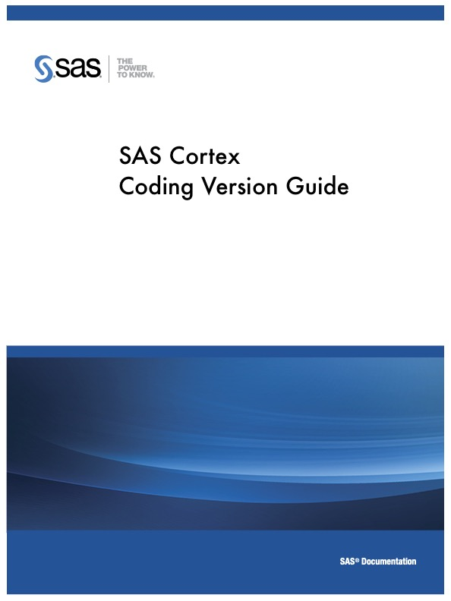

Table of Contents

Disclaimer 3

Support 3

How to play Cortex in SAS OnDemand for Academics (ODA) 4

How to play Cortex in Python Command 5

Install SASPy on Windows 6

Install SASPy on MAC 16

Access to Dataset 21

Round 1 - Game Summary 23

Round 1 - Model Description (SAS) 24

Step 1: Data Merge 24

Step 2: Data Partition 25

Step 3: Model Building 25

Step 4: Model Comparison 25

Step 5: Scoring Data 26

Step 6: Export Results 26

Round 1 - Model Description (Python) 26

Step 1: Data Merge 27

Step 2: Data Partition 27

Step 3: Model Building 28

Step 4: Model Comparison 29

Step 5: Scoring Data 29

Step 6: Export Results 29

Round 1 - Upload Decisions 30

Round 2 - Game Summary 36

Round 2 – Amount Model Description (SAS) 37

Step 1: Data Merge 37

Step 2: Data Partition 38

Step 3: Model Building 38

Step 4: Model Comparison 38

Step 5: Scoring Data 39

Step 6: Export Results 39

Round 2 – Probability Model Description (SAS) 40

Step 1: Data Merge 40

Step 2: Data Partition 41

Step 3: Model Building 42

Step 4: Model Comparison 42

Step 5: Scoring Data 43

Step 6: Export Results 43

Round 2 - Amount Model Description (Python) 44

Step 1: Data Merge 44

Step 2: Data Partition 44

Step 3: Model Building 45

Step 4: Model Comparison 46

Step 5: Scoring Data 46

Step 6: Export Results 46

Round 2 - Amount Model Description (Python) 47

Step 1: Data Merge 47

Step 2: Data Partition 47

Step 3: Model Building 48

Step 4: Model Comparison 49

Step 5: Scoring Data 49

Step 6: Export Results 50

Round 2 - Upload Decisions 50

Dataset Modification: 53

# Disclaimer

This user guide is intended to assist participants to play the game. The reader should not rely solely on the manual’s content to play the game. Players should have experience in either SAS or Python programming before playing the game.

# Support

For questions regarding access to SAS OnDemand for Academics, please reach out to SAS Support: [SASoda@sas.com](mailto:SASoda@sas.com). Additional resources and support can be found here: <https://support.sas.com/en/software/ondemand-for-academics-support.html#get-help>

If you choose to play the game with open-source software, SAS support is not available.

# How to play Cortex in SAS OnDemand for Academics (ODA)

You can play the game by coding the projection model in SAS at SAS Studio. As a first step, please create your account for ODA. To register, visit <https://odamid.oda.sas.com> and click on **“Don't have a SAS Profile?”** to create your profile and register for an account.

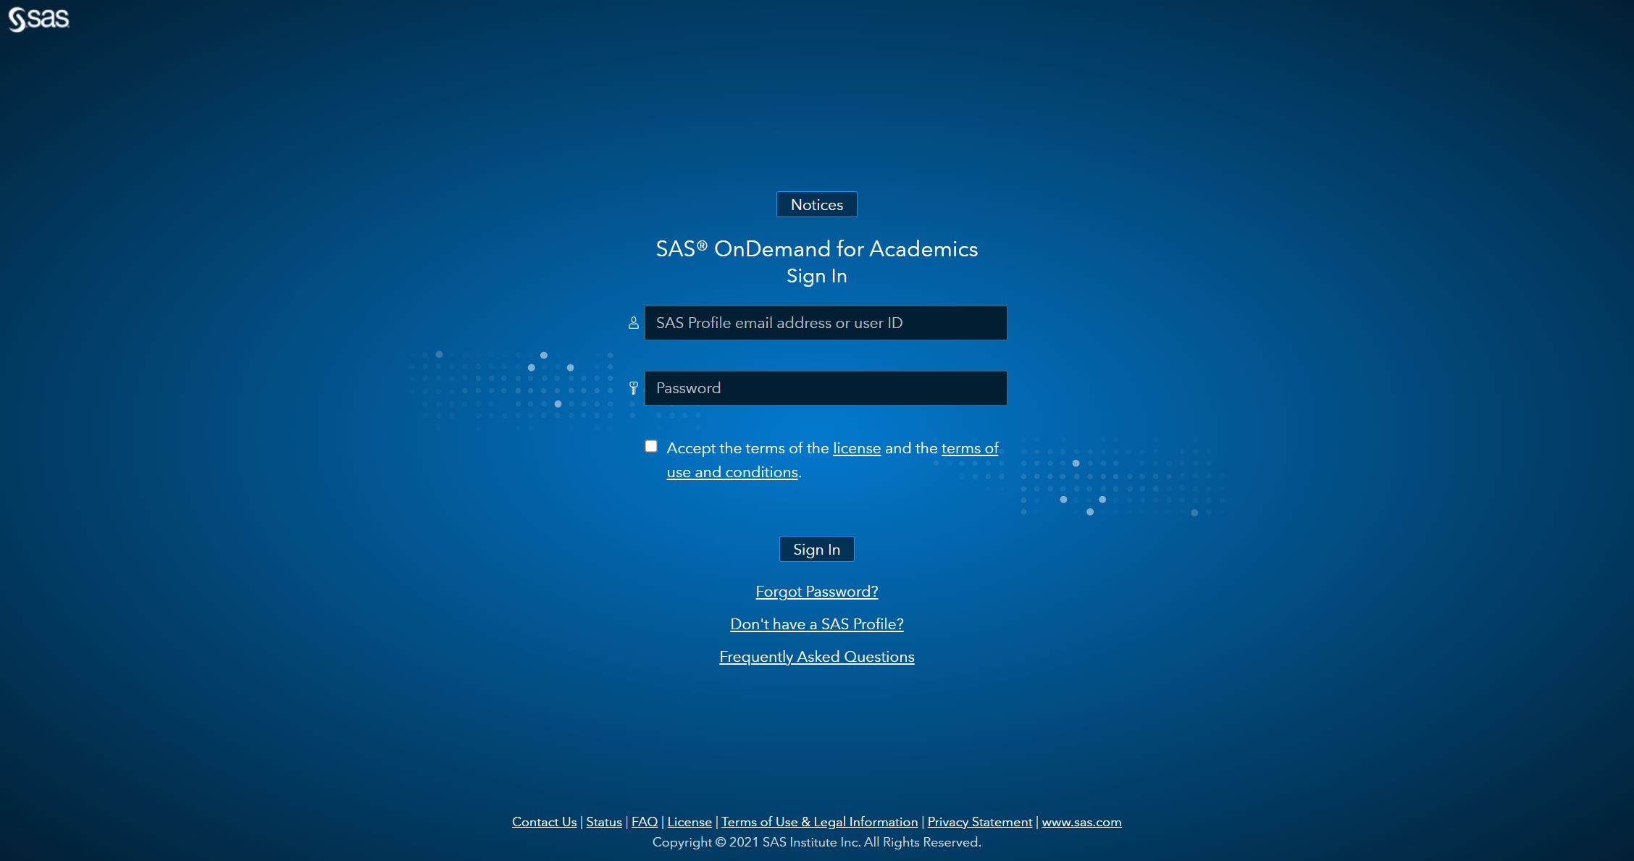

After you successfully create your account, you should be able to sign on the Control Center at <https://odamid.oda.sas.com>, and click “SAS Studio” to start coding.

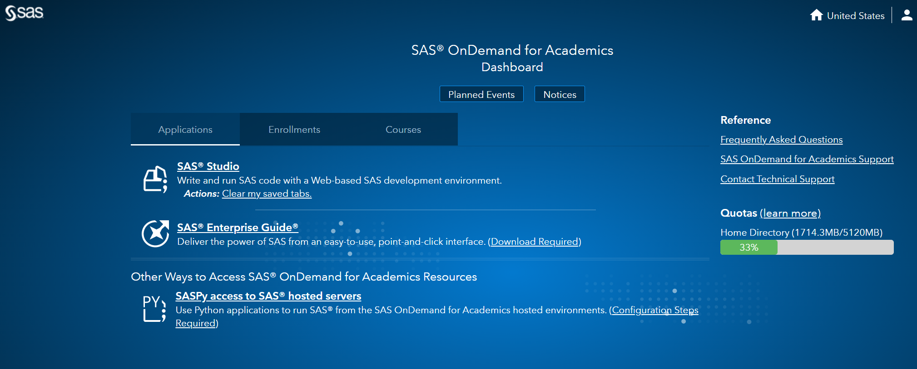

You will be provided a baseline model of SAS code to start with, you can modify the code to achieve the goal of the game – maximizing the donation amount. To play the game in SAS, please jump to the “**Access to the Dataset**” section.

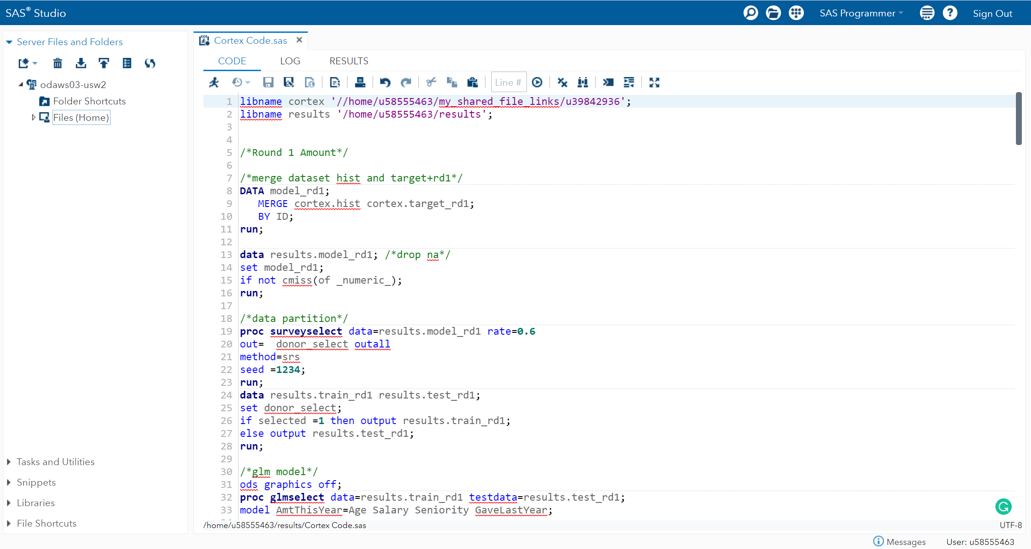

# How to play Cortex in Python Command

You can play the game by coding the projection model in Python. You will need to first establish connection between ODA and Python Command to access datasets in SAS terminal, more details are listed below. We will provide the baseline model of Python code in Jupyter Notebook. Python players will be expected to install Jupyter Notebook to continue the game.

After you successfully open the Jupyter Notebook, you can download the Python code of the baseline model from [Github](https://github.com/morrmarco/Cortex-Coding-Beta), you can modify the code to achieve the goal of the game – maximizing the donation amount.

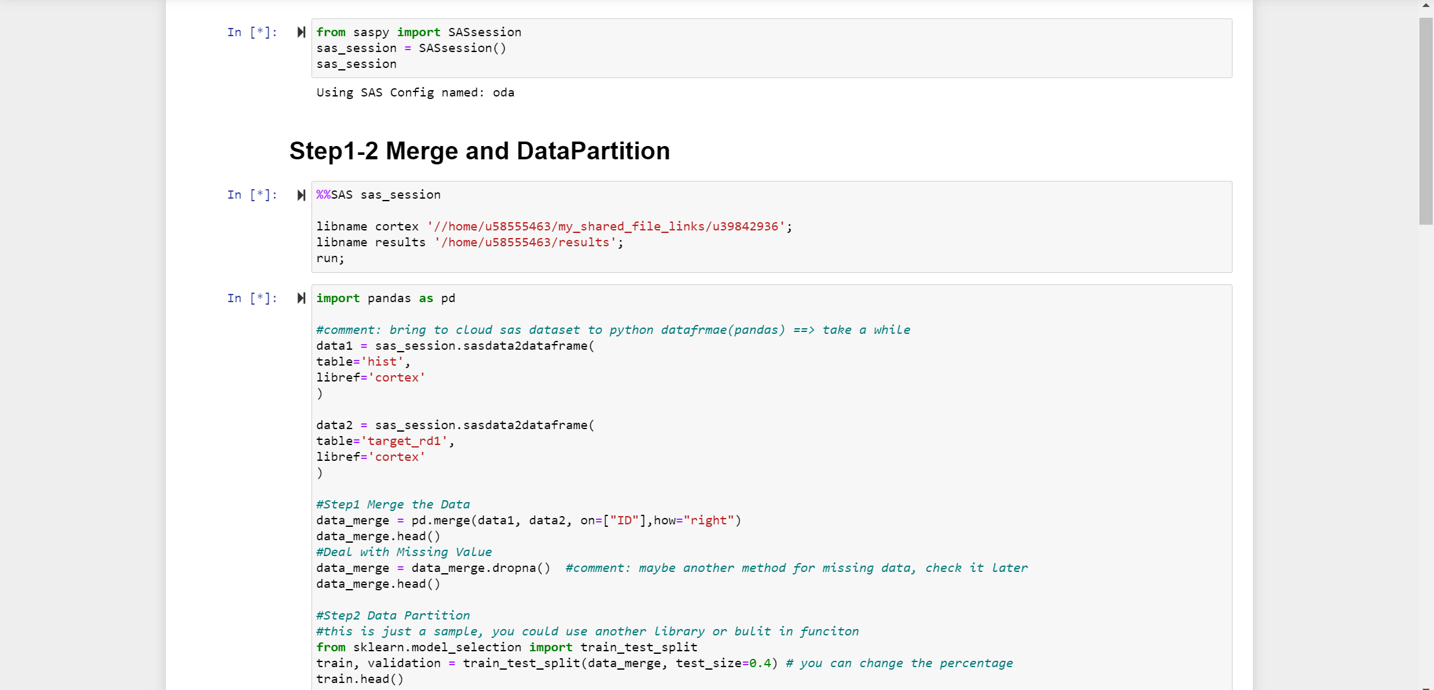

SASPy Installation and Configuration

To install the SASPy in your Python Command, you need to ensure that you meet the prerequisite:

1. Java version 1.8.0_162 or higher
2. Python 3.3 or higher
3. SASPy 3.3.4 or higher

If you do not have Java installed, click [here](https://www.java.com/en/) to download and install the newest version of Java.

If you do not have Jupyter Notebook installed, click [here](https://docs.anaconda.com/anaconda/install/index.html) to download and install the newest version of Anaconda Prompt and open Jupyter Notebook.

You can also click [here](https://www.dropbox.com/sh/5xq46b9d58k7o9g/AADTQA65Ub-Q-YGMxWq74s6-a?dl=0) to see the instructional videos of SASPy installation.

### Install SASPy on Windows

You can open Jupyter Notebook from the Anaconda Prompt and create a new Python 3 Notebook in your Jupyter Notebook Web page.

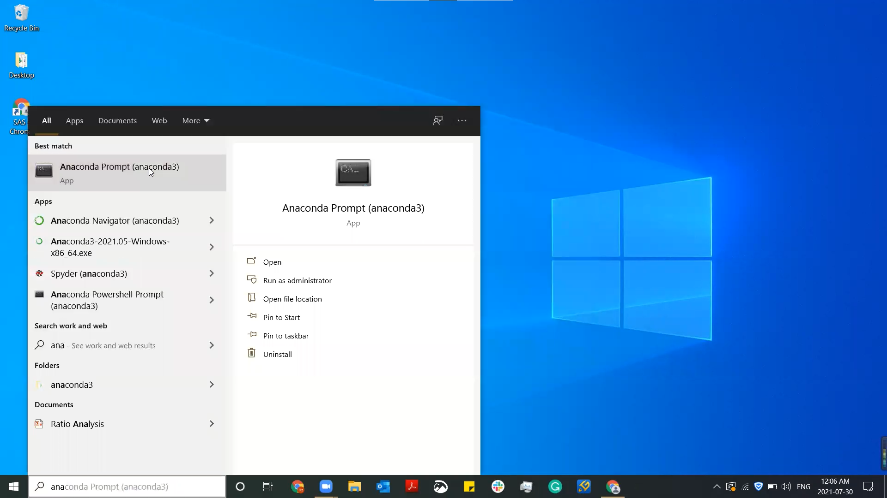

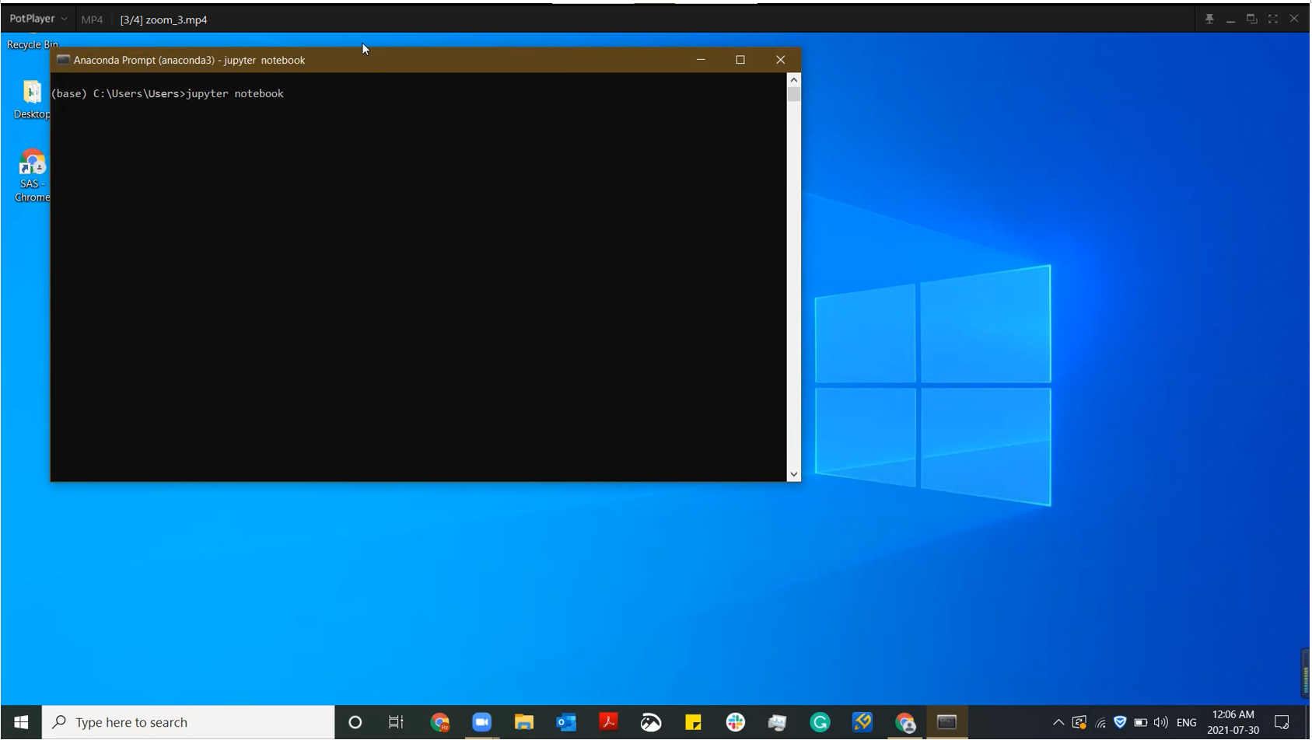

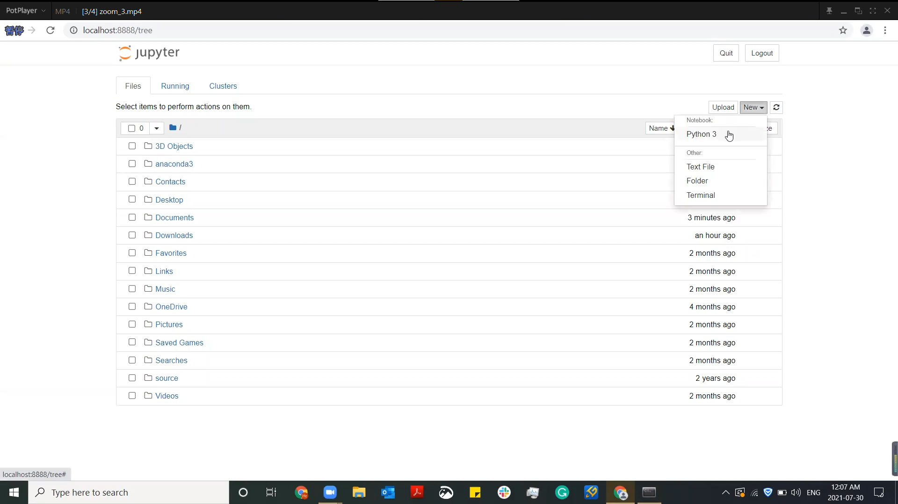

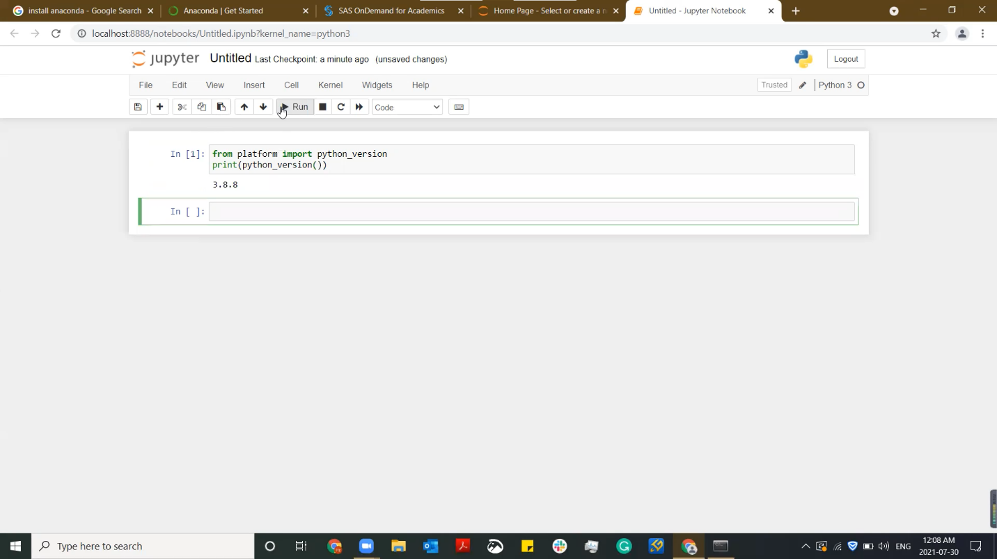Execute the code below to check your Python version, if it is higher than 3.4, PIP is already installed, if not, update your Python to so that you can use PIP to install the SASPy package.

PIP is already installed.

from platform import python_version

print (python_version())

Execute the code ***pip install saspy*** in the Jupyter Notebook to install SASPy.

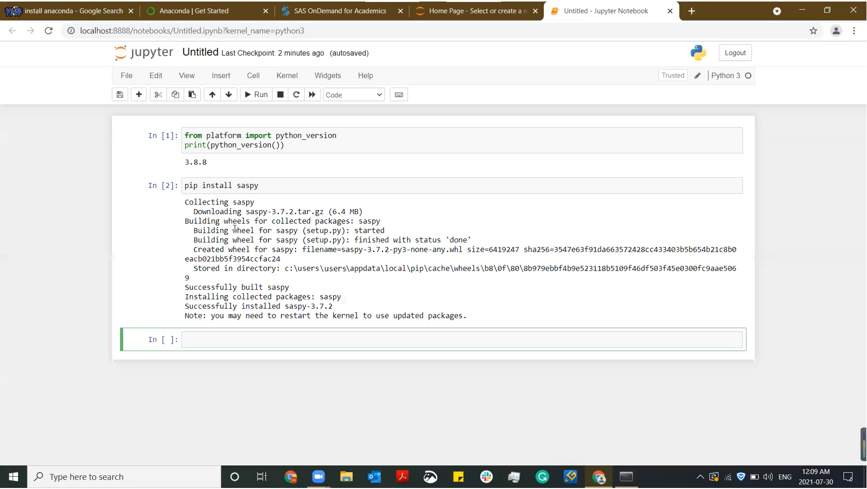

Click [here](https://support.sas.com/ondemand/saspy.html) to open the SASPy support page, copy the highlighted text and paste it to a newly created text editor.

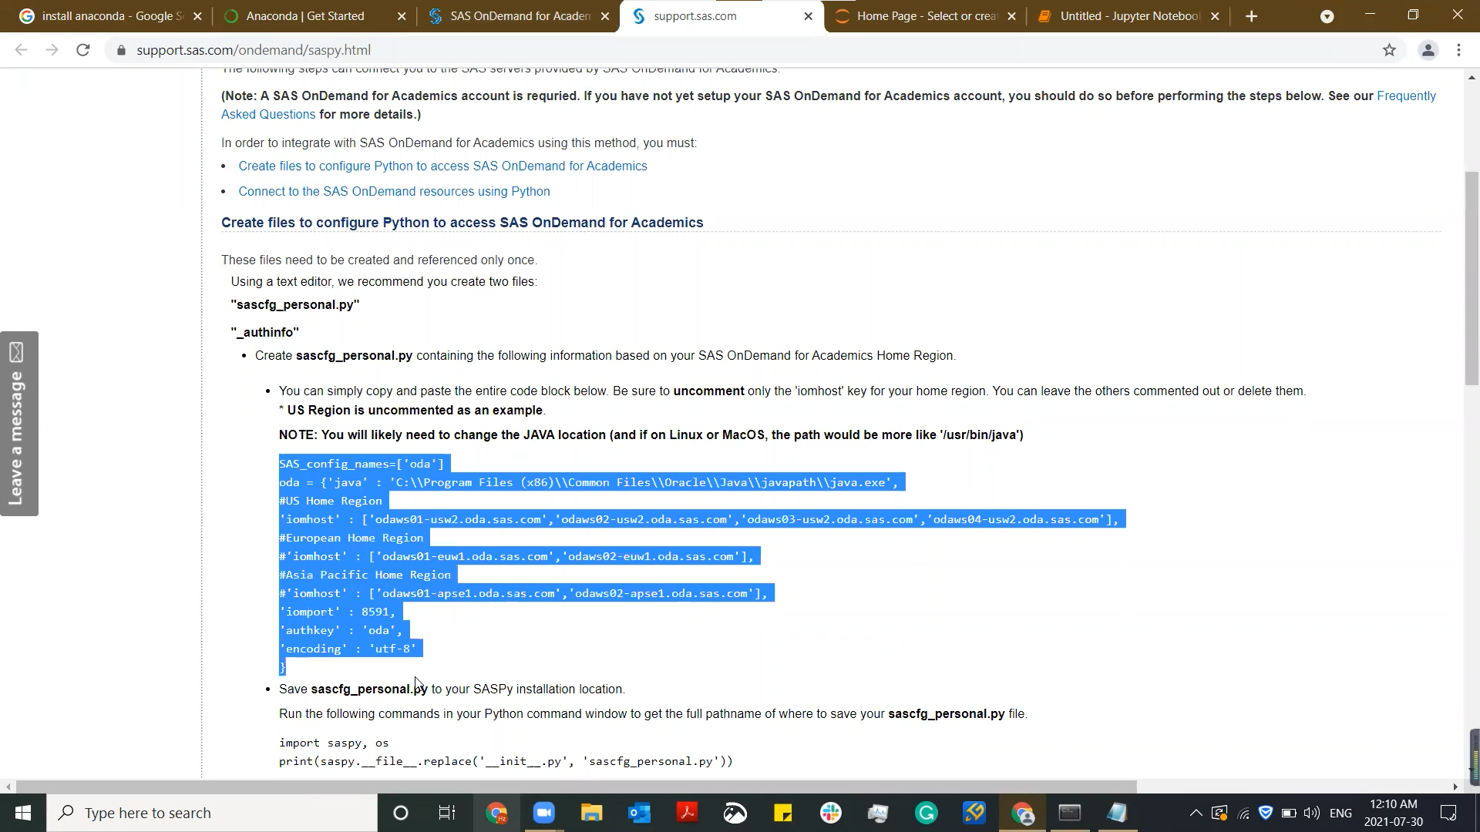

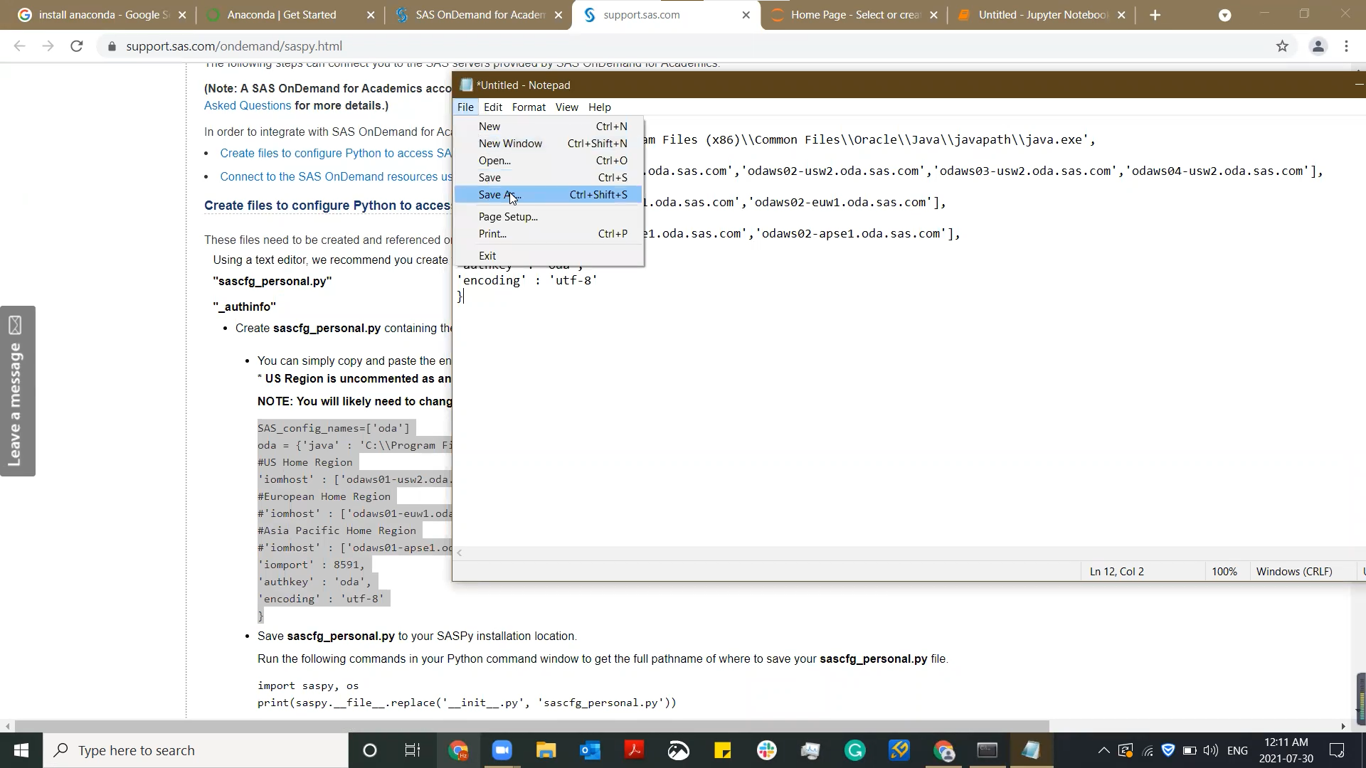

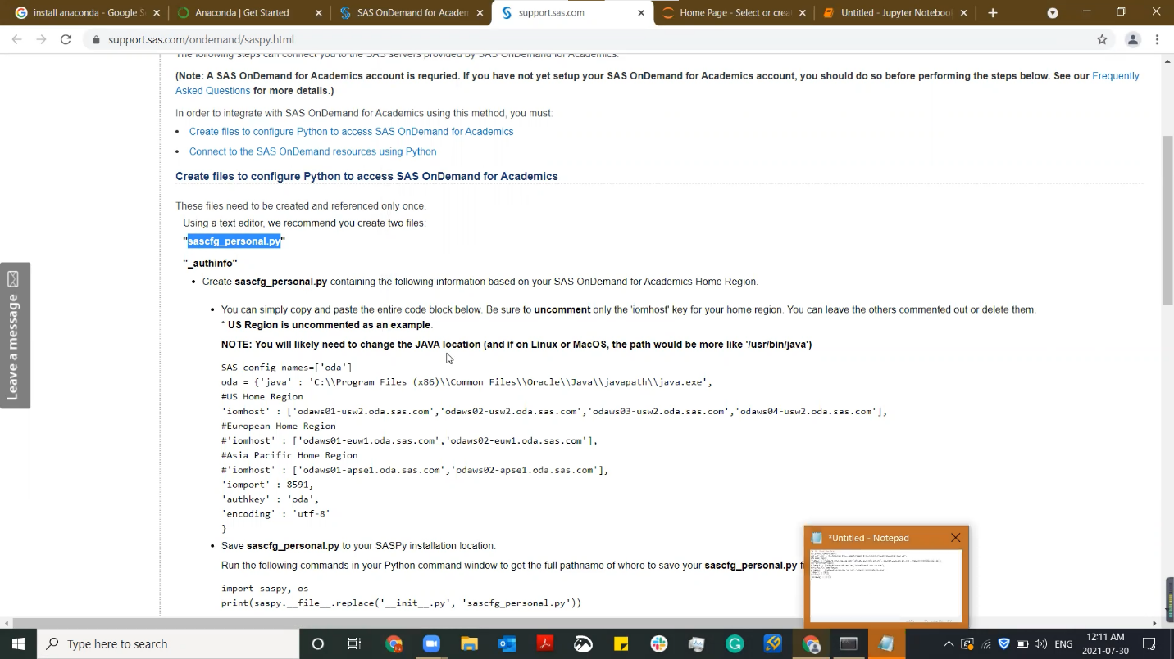Save the text editor named ***sascfg_personal.py*** to your SASPy installation location, you can find this location by running the code ***pip install saspy*** again in the Jupyter Notebook. You need to change the file type to All Files before you save it, if the Notepad in your Windows does not allow you to do so, [download **Notepad++**](https://notepad-plus-plus.org/downloads/)for this file creation.

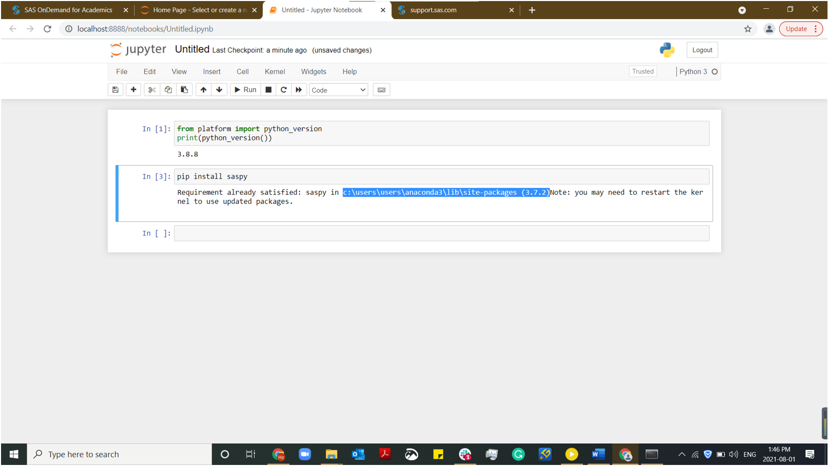

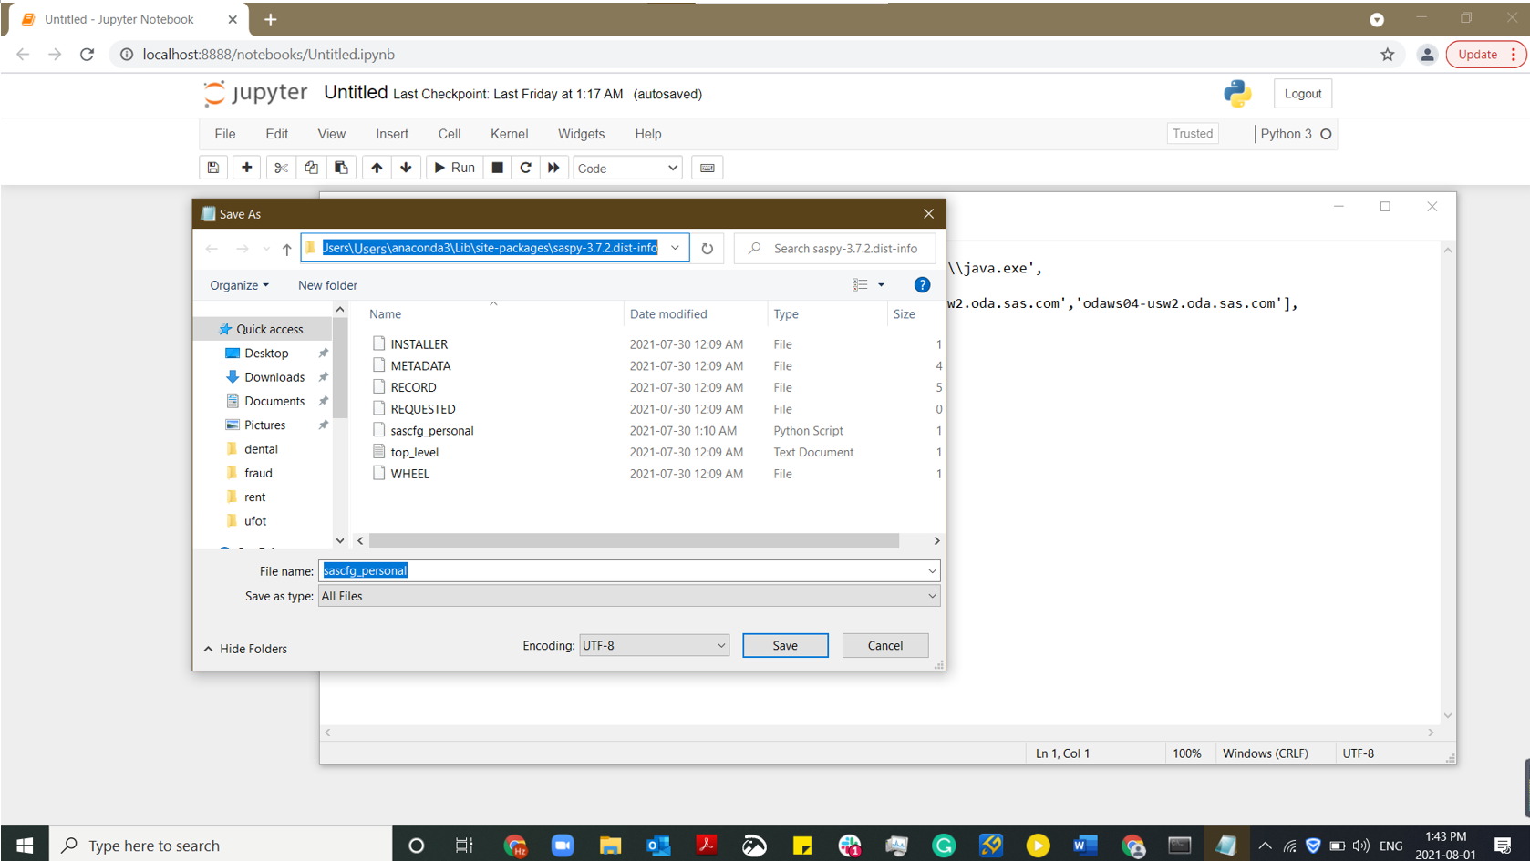

Create another text editor, copy the text highlighted below and paste it to this new text editor.

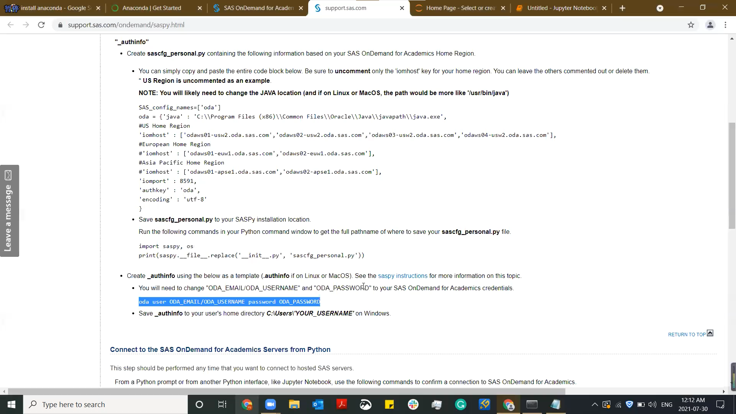

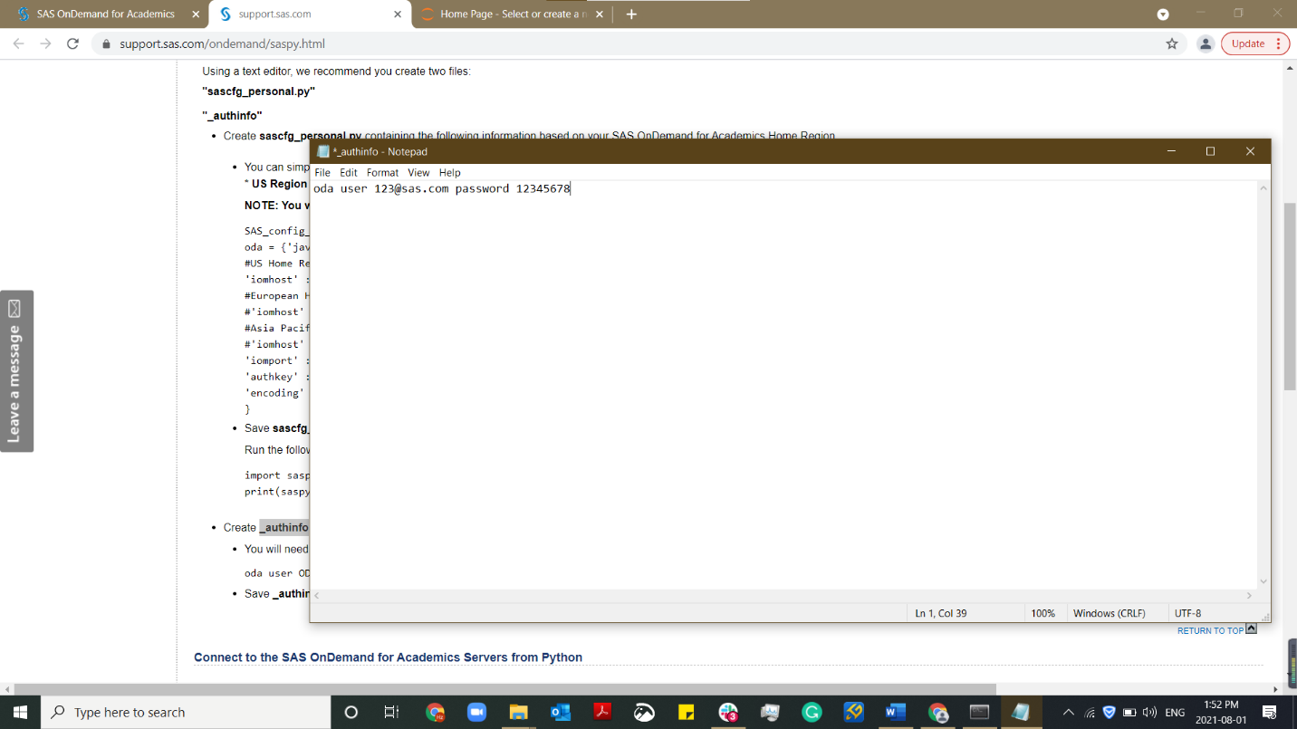You will need to change ***ODA_EMAIL/ODA_USERNAME*** and ***ODA_PASSWORD*** to your ODA credentials, for example, if your ODA email is [123@sas.com](mailto:123@sas.com) and your ODA password is 12345678, your text editor will look like this.

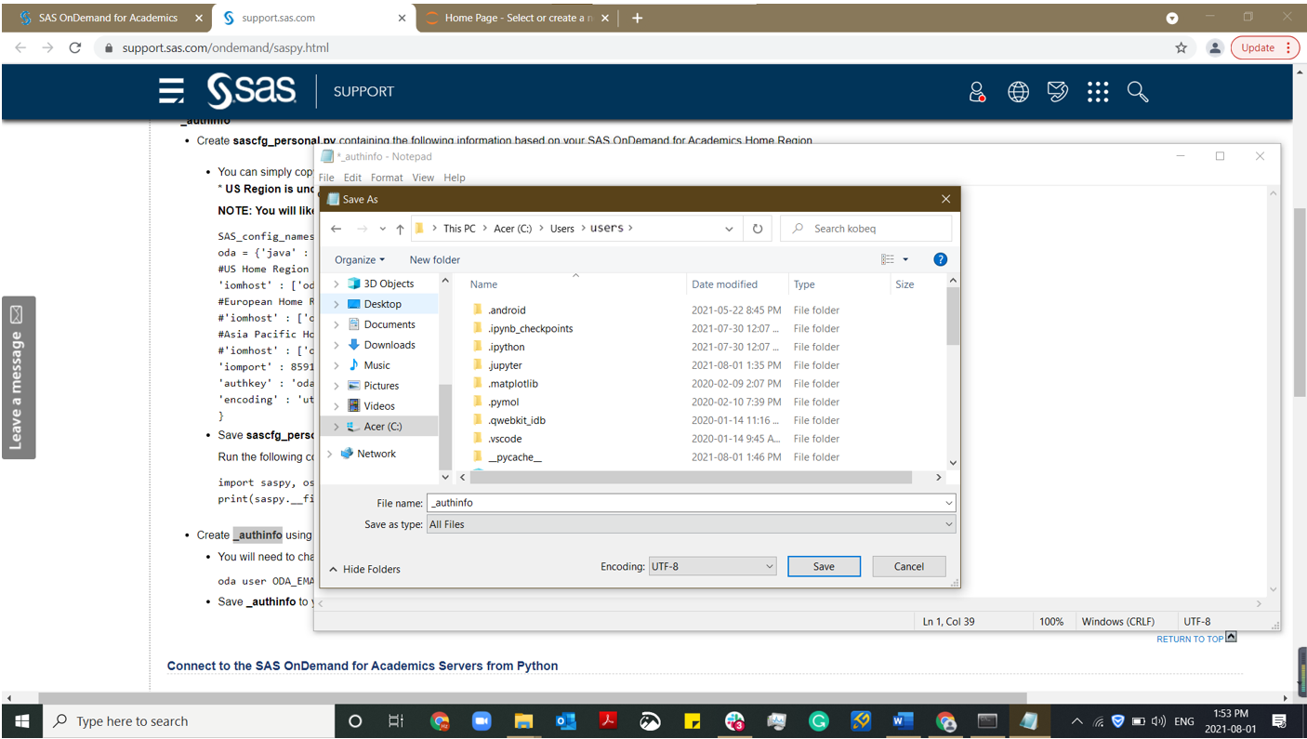Save ***_authinfo*** to your user's home directory *C:\Users\'YOUR_USERNAME'* on Windows. You need to change the file type to All Files before you save it.

From a Python prompt or from another Python interface, like Jupyter Notebook, use the following commands to confirm a connection to ODA. ***This step should be performed each time that you want to connect to hosted SAS servers.***

import saspy

sas_session = saspy.SASsession()

sas_session

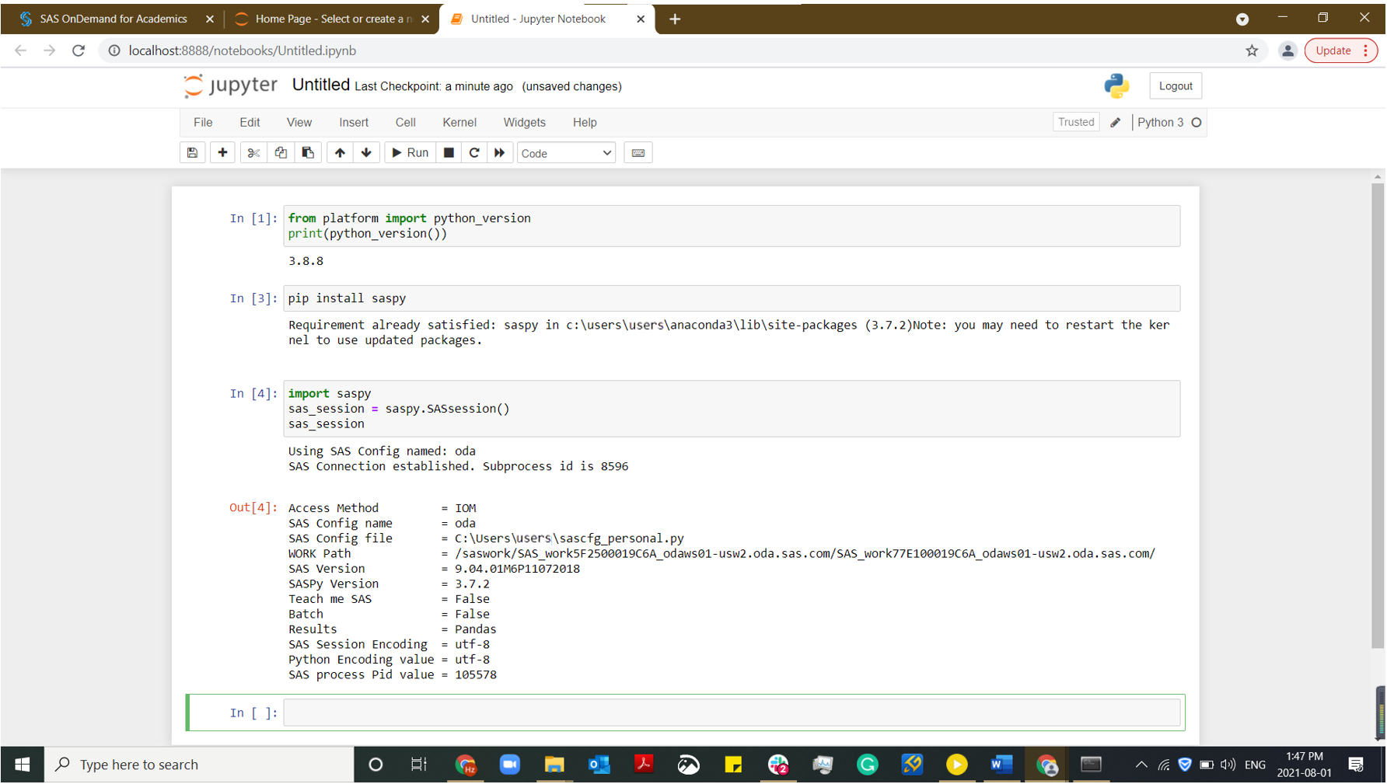

Note: If you encounter, **"*None of the requested encryption algorithms are supported by both peers: AES*"**, please confirm you are running the correct version of Java (1.8.0_162 or greater) and Contact Us for additional assistance.

### Install SASPy on MAC

Download Anaconda [here.](https://docs.anaconda.com/anaconda/install/index.html) Launch Jupyter Notebook from the Anaconda Navigator.

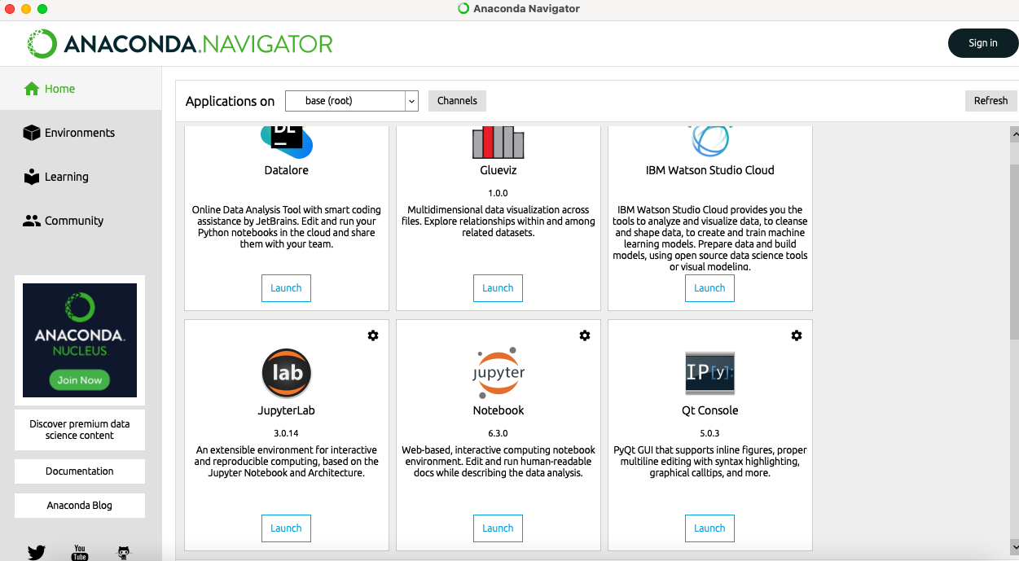

Create a new Python 3 Notebook in your Jupyter Notebook Web page.

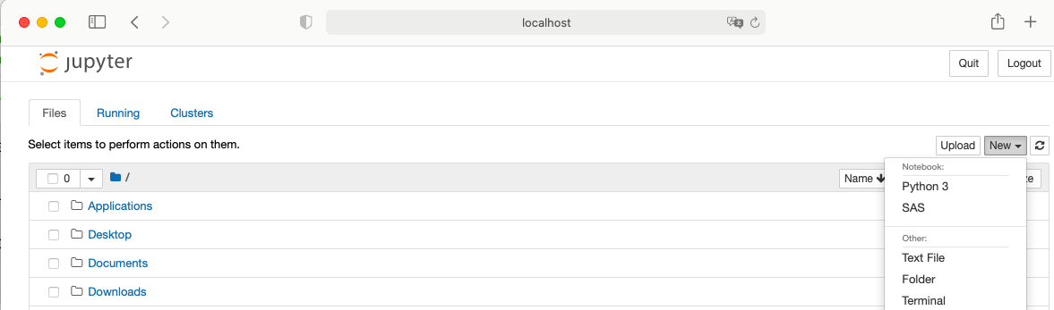

Execute the code below to check your Python version, if it is higher than 3.4, PIP is already installed, if not, update your Python to so that you can use PIP to install the SASPy package.

from platform import python_version

print (python_version())

PIP is already installed.

Execute the code ***pip install saspy*** in the Jupyter Notebook to install SASPy.

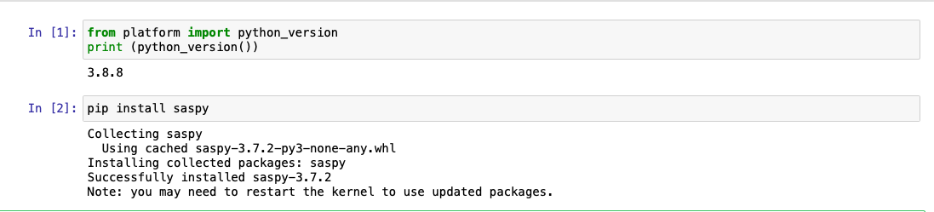

You will need to create 2 configuration files in total (***sascfg_personal.py*** & ***.authinfo***) and this step is for ***sascfg_personal.py*** file.

1. 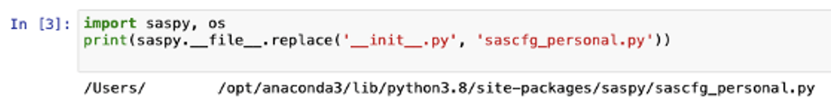Run the following commands in your Jupyter Notebook to get the full pathname of where to save your ***sascfg_personal.py*** file. Copy the path you got.

import saspy, os

print(saspy.__file__.replace('__init__.py', 'sascfg_personal.py'))

1. Open your Terminal and start a new window

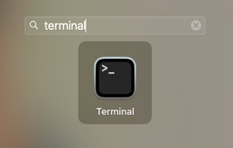 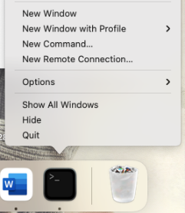

1. Type Command ***vim FULLPATH*** in the Terminal to create sascfg_personal.py at the path got in step 1. You will need to change ***FULLPATH*** to your unique path got from Step 1.

For example, given the path achieved in previous picture, you will enter:

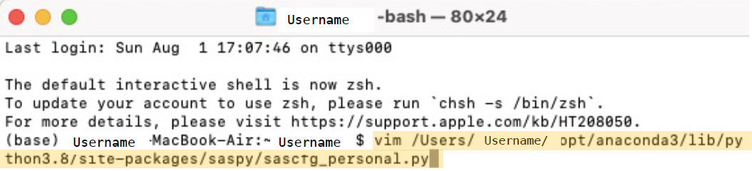*vim /users/username/opt/anaconda3/lib/python3.8/site-packages/saspy/sascfg_personal.py*

1. Press “***a***” to enter edit mode
2. Copy and paste the grey code block below. Be sure to uncomment only the 'iomhost' key for your home region. **\*US Region is uncommented as an example.** You can leave the others commented out or delete them.

**NOTE: You will likely need to change the JAVA location. For MAC users, your Java path is usually *‘/usr/bin/java’***

SAS_config_names=['oda']

oda = {'java' : '/usr/bin/java',

#US Home Region

'iomhost' : ['odaws01-usw2.oda.sas.com','odaws02-usw2.oda.sas.com','odaws03-usw2.oda.sas.com','odaws04-usw2.oda.sas.com'],

#European Home Region

#'iomhost' : ['odaws01-euw1.oda.sas.com','odaws02-euw1.oda.sas.com'],

#Asia Pacific Home Region

#'iomhost' : ['odaws01-apse1.oda.sas.com','odaws02-apse1.oda.sas.com'],

'iomport' : 8591,

'authkey' : 'oda',

'encoding' : 'utf-8'

}

1. 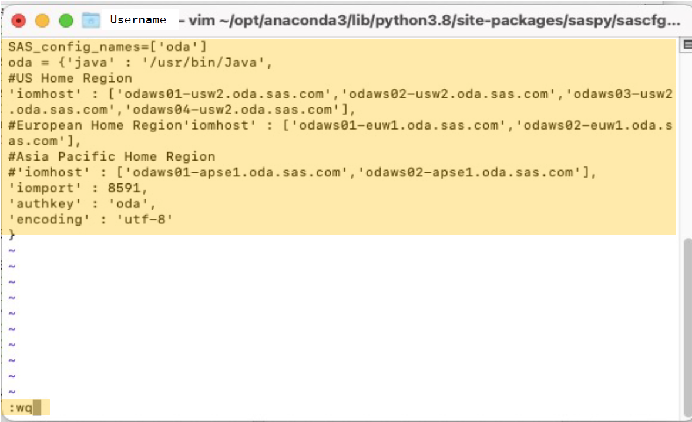Hit ***“Esc”*** and then type ***:wq*** and then hit ***“Enter ”***save and quit.

You will need to create 2 configuration files in total (***sascfg_personal.py* &** ***.authinfo***) and this step is for ***.authinfo*** file.

1. Open Terminal and type command ***vim ~/.authinfo***

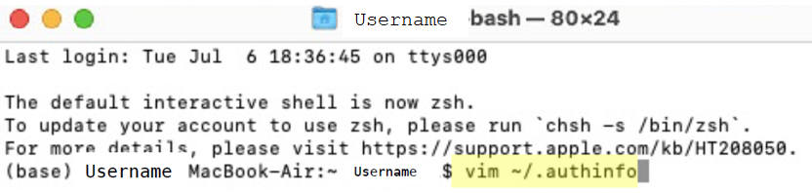

1. Press “***a***” to enter edit mode.
2. Type in the following text, use the coding block below as a template. You will need to change ***ODA_EMAIL/ODA_USERNAME*** and ***ODA_PASSWORD*** to your SAS OnDemand for Academics credentials



oda user ***ODA_EMAIL/ODA_USERNAME*** password ***ODA_PASSWORD***

1. Press ***“Esc”*** and then type **:wq** and then hit ***“Enter”*** to save the file and quit.

Open Python prompt or from another Python interface, like Jupyter Notebook. Use the following commands to confirm a connection to ODA.***This step should be performed each time that you want to connect to hosted SAS servers.***

import saspy

sas_session = saspy.SASsession()

sas_session

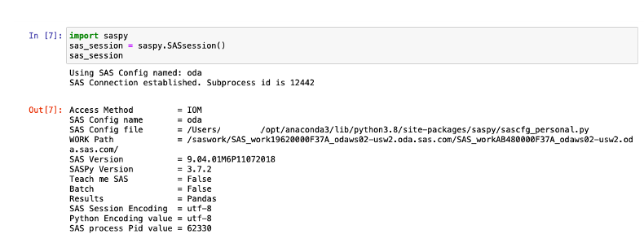

Note: If you encounter, **"*None of the requested encryption algorithms are supported by both peers: AES*"**, please confirm you are running the correct version of Java (1.8.0_162 or greater) and Contact Us for additional assistance.

# Access to Dataset

To access the dataset in the SAS terminal, you need to follow these steps:

1. Sign on the Control Center at <https://odamid.oda.sas.com>.
2. Look for the Enroll in a course link in the "Enrollments" section near the bottom of the page. Click this link to start the enrollment.
3. Enter the course code: **83fd3afd-8964-4f5b-a612-7b665ed69104**

Then you can open your SAS Studio interface and open the “my_shared_file_links” folder, you can see all the cortex dataset in the folder named “Cortex Data Sets” under the “u39842936” folder.

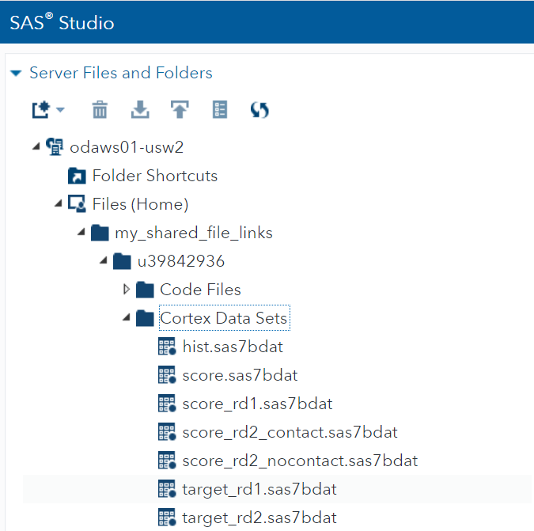

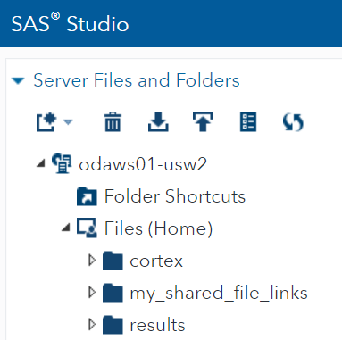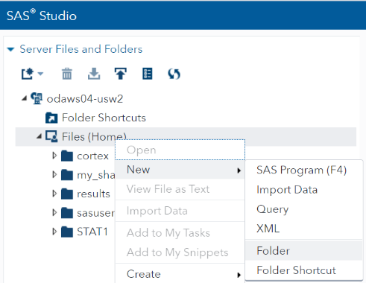After that, you need to create a folder named “results”. This is important because you do not have the authority to do any edit/change to the datasets in that folder “u39842936”. Please restore any interim datasets to the 'work' or 'results' library.

Copy the path of “u39842936” folder and create “cortex” library by code: libname cortex '/***path***';

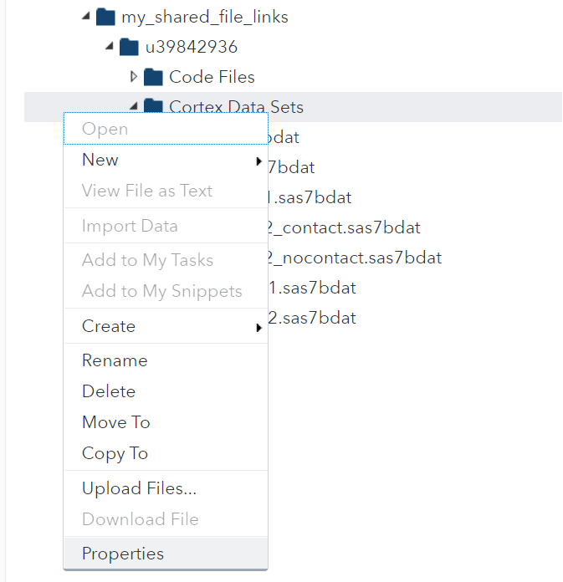 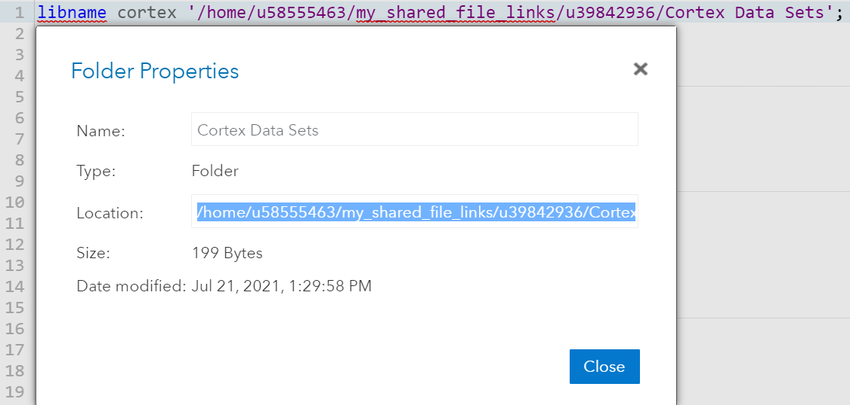

Copy the path of “results” folder and create “results” library by code: libname cortex '/***path***'; then you can restore any interim dataset to the “results” folder & library.

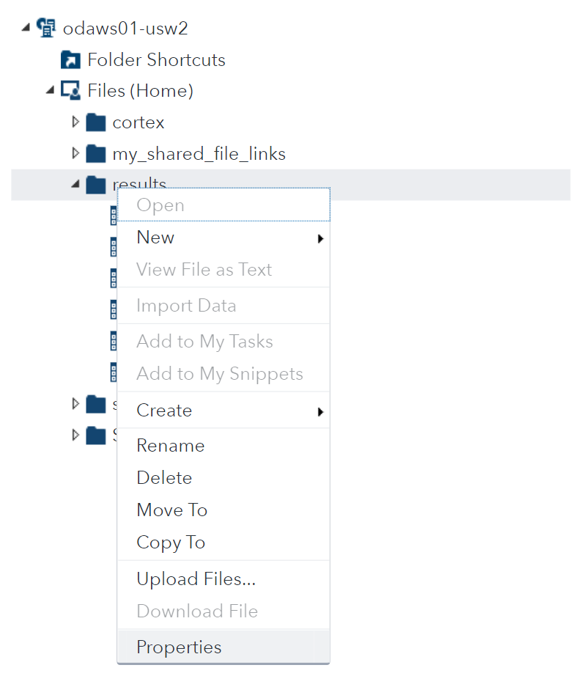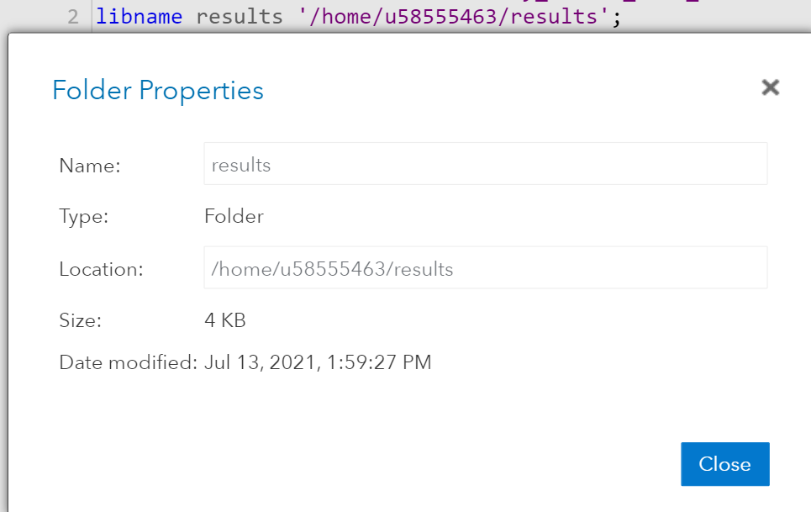

[Link for Reference](https://documentation.sas.com/doc/en/pgmsascdc/v_014/lestmtsglobal/n1nk65k2vsfmxfn1wu17fntzszbp.htm?fromDefault=)

You can then start coding in the SAS Studio.

If you want to use Python Command for coding, you need to connect your SAS terminal to the Python Command using SASPy, then you need to add this code ***%%SAS sas_session*** and create “cortex” library in SAS language to access datasets in SAS terminal. You don’t need to create “results” library in Jupyter Notebook.

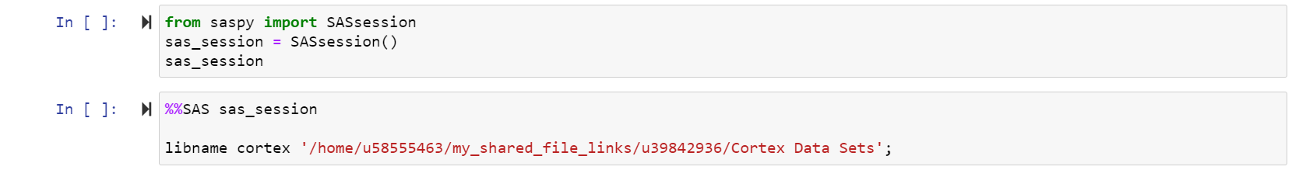

# Round 1 - Game Summary

In Round 1, your mission is to predict the amount that each member would give next year to the foundation. You would then use this prediction to call the most valuable members (i.e., members who are predicted to give the most to the foundation).

# Round 1 - Model Description (SAS)

There are 6 steps for game completion: Data Merge, Data Partition, Model Building, Model Comparison, Scoring Data and Export Results. Check Data Modification for more SAS resources. Note: below is a screenshot of the Cortex flow from SAS Enterprise Miner. This provides a good overview of the analytics processes used throughout the game. It is for your reference only; you will not see this in SAS Studio.

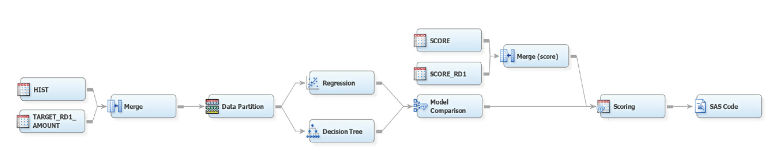

### Step 1: Data Merge

The first step is to merge two datasets into one for better modification. You need to deal with missing values after merging the datasets so that you proceed can to the next step — Data Partition.

You can use other way to deal with missing values

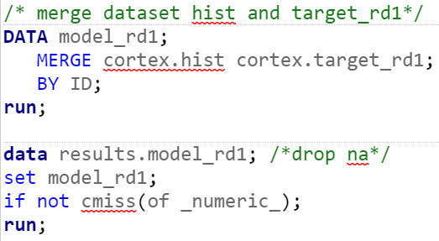

[Link for Reference](https://documentation.sas.com/doc/en/pgmsascdc/9.4_3.3/statug/statug_surveyselect_toc.htm)

### Step 2: Data Partition

The second step is data partition, this will help the model to increase its performance, please note that this is a default model, you can change the training and validation percentage for a better model performance.

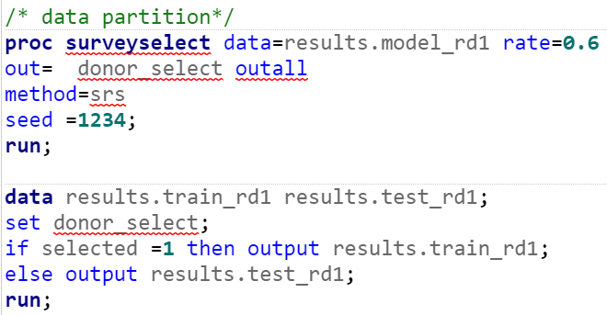

[Link for Reference](https://documentation.sas.com/doc/en/pgmsascdc/9.4_3.3/statug/statug_surveyselect_toc.htm)

### Step 3: Model Building

In this step, [linear regression](https://documentation.sas.com/doc/en/pgmsascdc/9.4_3.3/statug/statug_glmselect_syntax01.htm) and [decision tree](https://support.sas.com/documentation/solutions/emtmsas/94/emprcref.pdf) models are used for analysis, you can also choose other model methods (i.e., [logistic regression](https://documentation.sas.com/doc/en/pgmsascdc/9.4_3.3/statug/statug_logistic_gettingstarted.htm), [HP forest](https://documentation.sas.com/doc/en/pgmsascdc/9.4_3.3/emhpprcref/emhpprcref_hpforest_syntax.htm), [gradient boosting](https://video.sas.com/detail/video/5754395446001/training-gradient-boosting-models-in-model-studio)) to predict the amount donated. We recommend you perform a descriptive analysis to select independent variables for prediction.

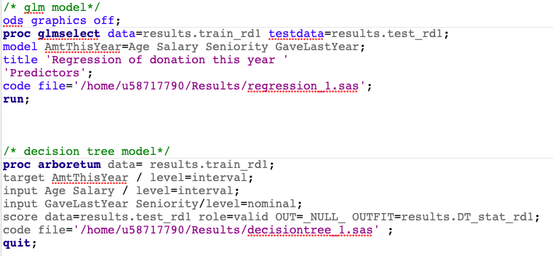

### Step 4: Model Comparison

When comparing models, you can click RESULTS tab for comparison, SAS will compute statistics automatically, you can then choose [different criteria](https://blogs.sas.com/content/iml/2019/01/30/model-validation-machine-learning.html) to determine which model fits better for prediction. In the default model, linear regression model is selected for scoring.

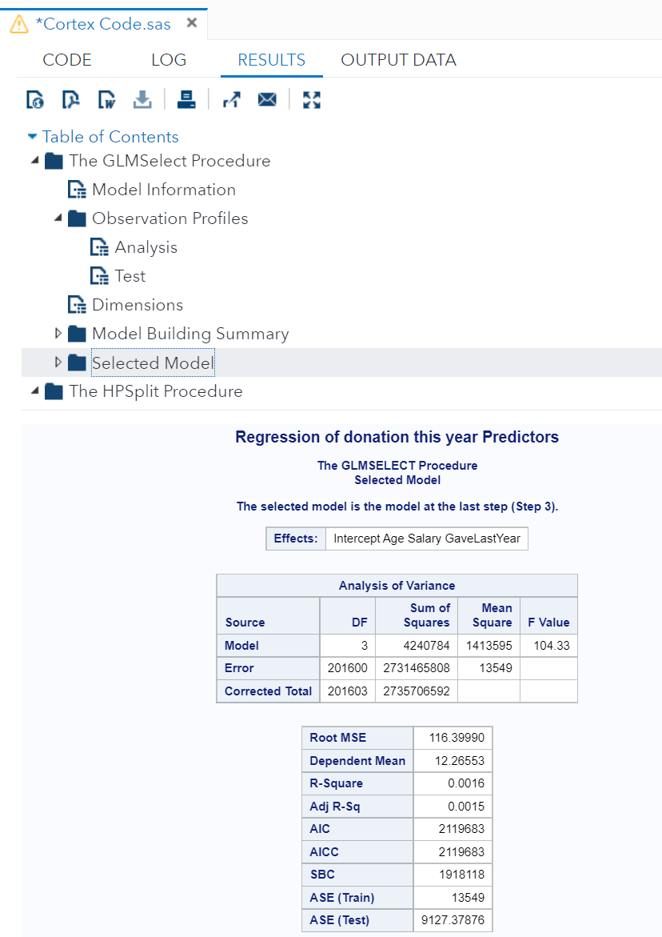

### Step 5: Scoring Data

Scoring new data to compute predictions for an existing model is a fundamental stage in the analytics life cycle, after you score out the dataset, you can export the model result for upload.

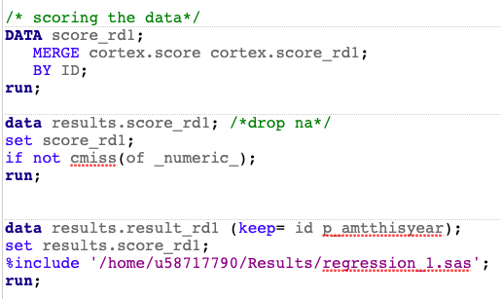

### Step 6: Export Results

Following code will help you to export the model result into a CSV file. You can sort the data by predicted amount in the descending order before export the file, this will help you determine number of donors you want to contact.

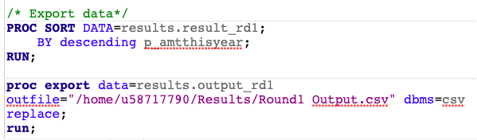

# Round 1 - Model Description (Python)

**NOTE**: You need to install ***saspy, pandas***, ***numpy***, and ***sklearn*** python packages to run the baseline model in your python command.

There are 6 steps for game completion: Data Merge, Data Partition, Model Building, Model Comparison, Scoring Data and Export Results. Note: below is a screenshot of the Cortex flow from SAS Enterprise Miner. This provides a good overview of the analytics processes used throughout the game. It is for your reference only; you will not see this in Python.



### Step 1: Data Merge

The first step is to merge two datasets into one for better modification. You need to deal with missing values after merging the datasets so that you can proceed to the next step — Data Partition.

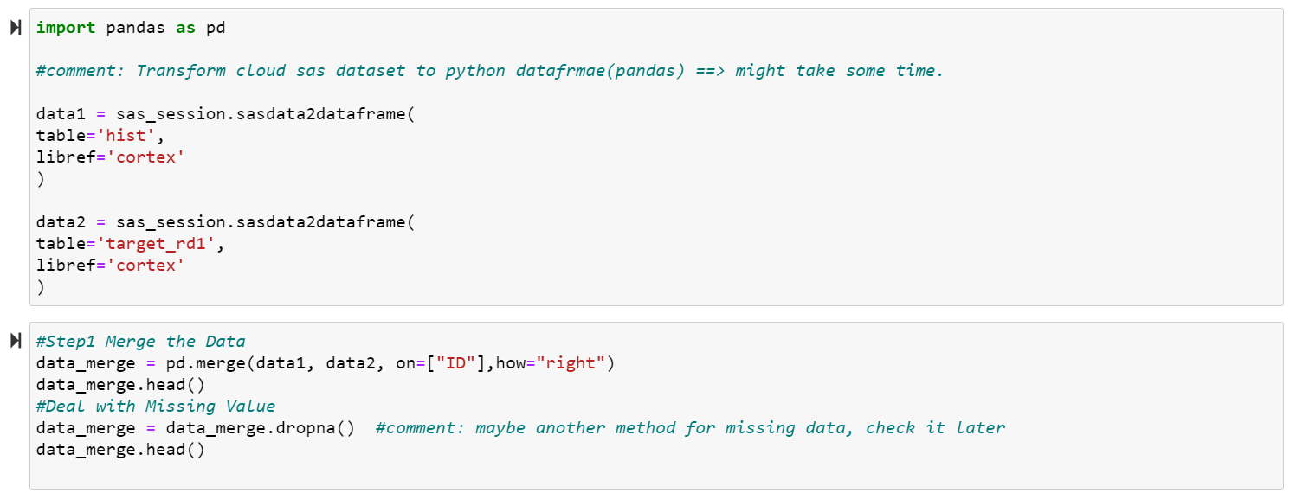

### Step 2: Data Partition

The second step is data partition, this will help the model to increase its performance, please note that this is a default model, you can change the training and validation percentage for a better model performance.

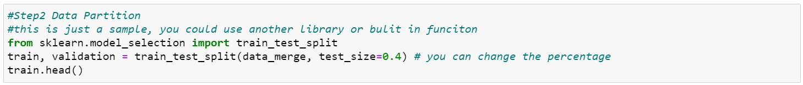

### Step 3: Model Building

In this step, linear regression and decision tree models are used for analysis, you can also choose other model methods (i.e., logistic regression, HP forest, gradient boosting) to predict the amount donated. We recommend you perform a descriptive analysis to select independent variables for prediction.

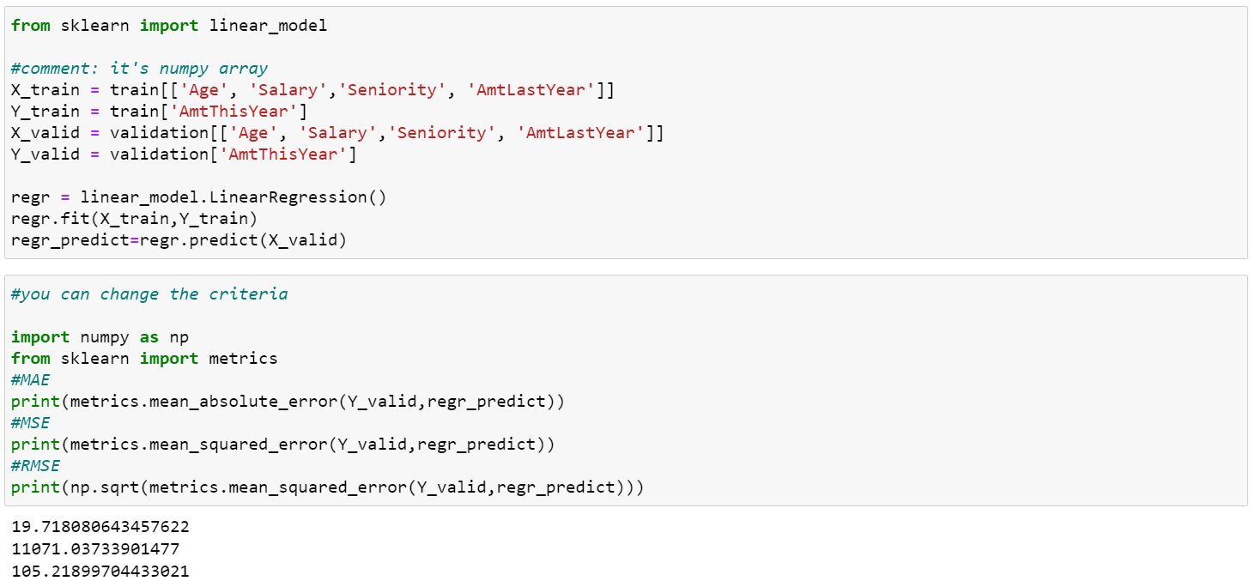

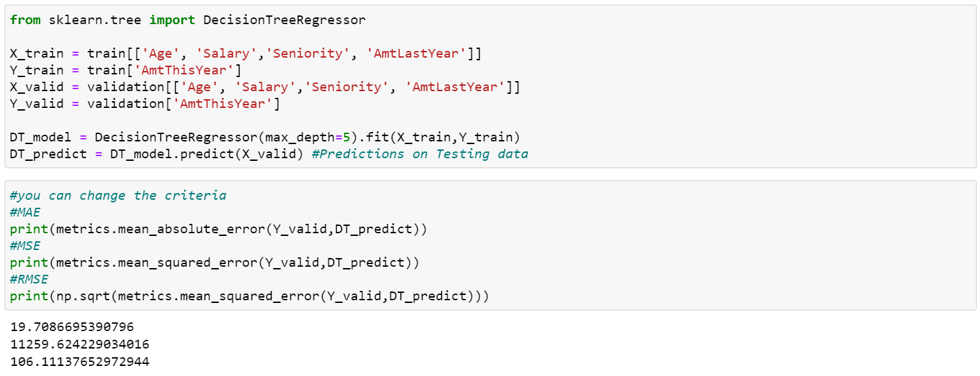

### Step 4: Model Comparison

When comparing models, you need to choose a criterion and calculate it manually to determine which model fits better for prediction since Python will not compute the statistical results automatically. In the default model, we compare the MSE of two model, and the linear regression model is selected for scoring.

### Step 5: Scoring Data

Scoring new data to compute predictions for an existing model is a fundamental stage in the analytics life cycle, after you score out the dataset, you can export the model result for upload.

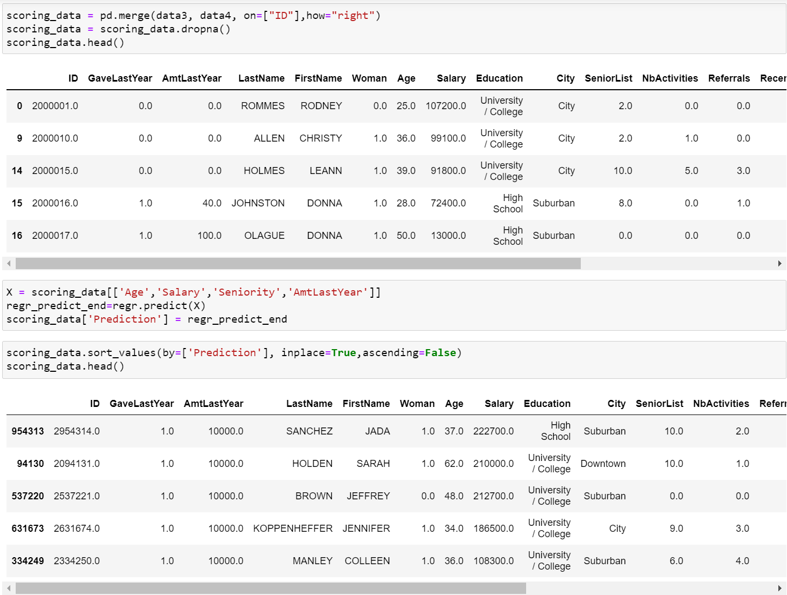

### Step 6: Export Results

Following code will help you to export the model result into a CSV file. You can sort the data by predicted amount in the descending order before export the file, this will help you determine number of donors you want to contact.



# Round 1 - Upload Decisions

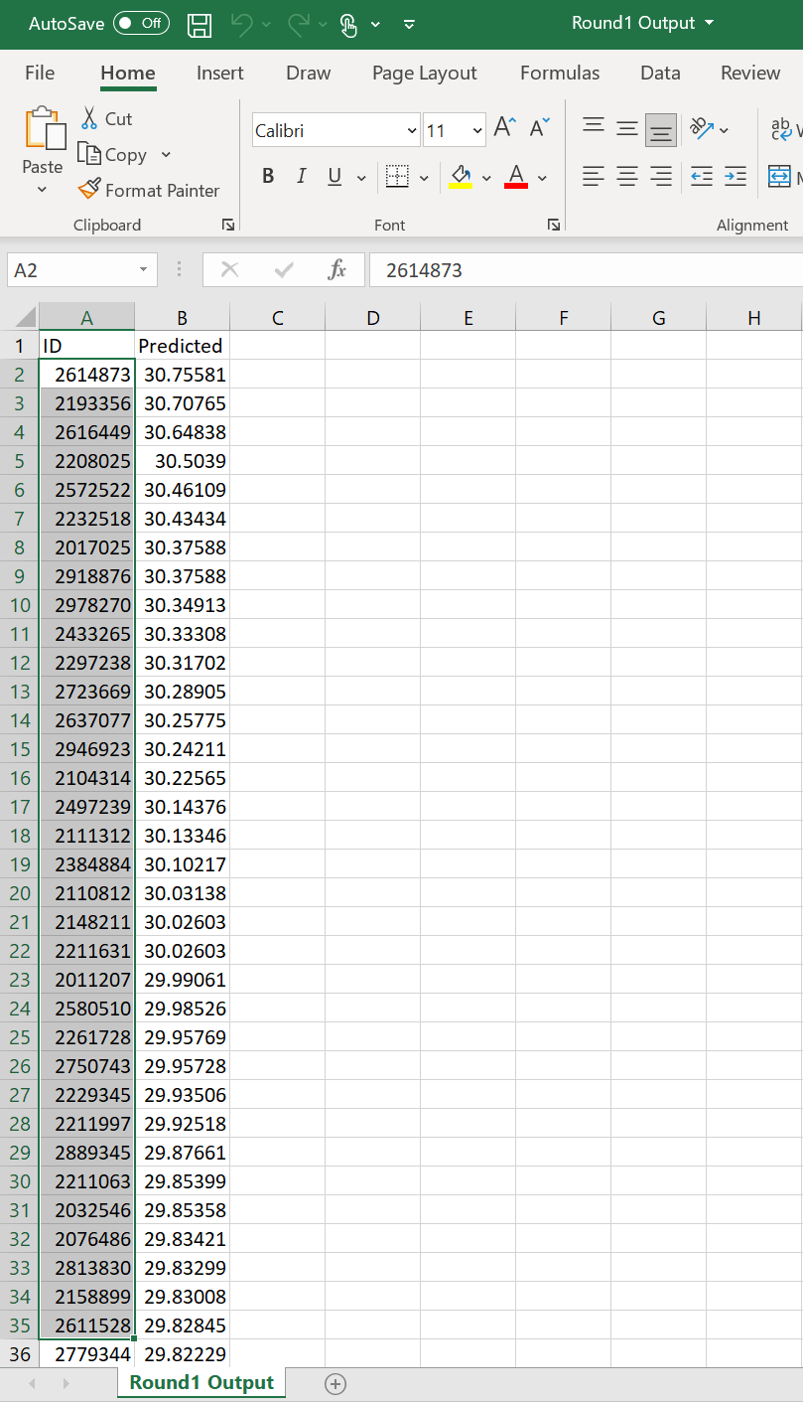After you export the result, you need to create a new CSV file, select the number of people you want to contact in the file exported, and copy the ID list ONLY to the new CSV file. You need to **SAVE** and **CLOSE** the new CSV file before uploading it to the game leaderboard.

Select ID numbers ONLY, paste them to a new CSV file.

Login to the Leaderboard: <https://edge.hec.ca/play/>

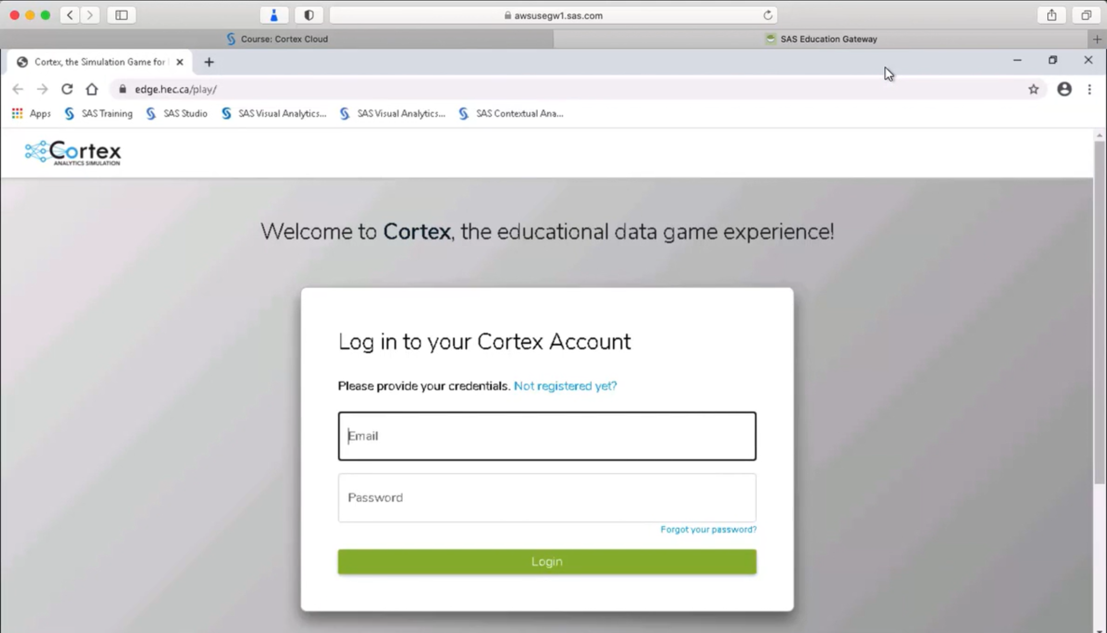

Once you login, click **Join a Game** button and enter the five digit game code. You should receive this from your professor or game administrator.

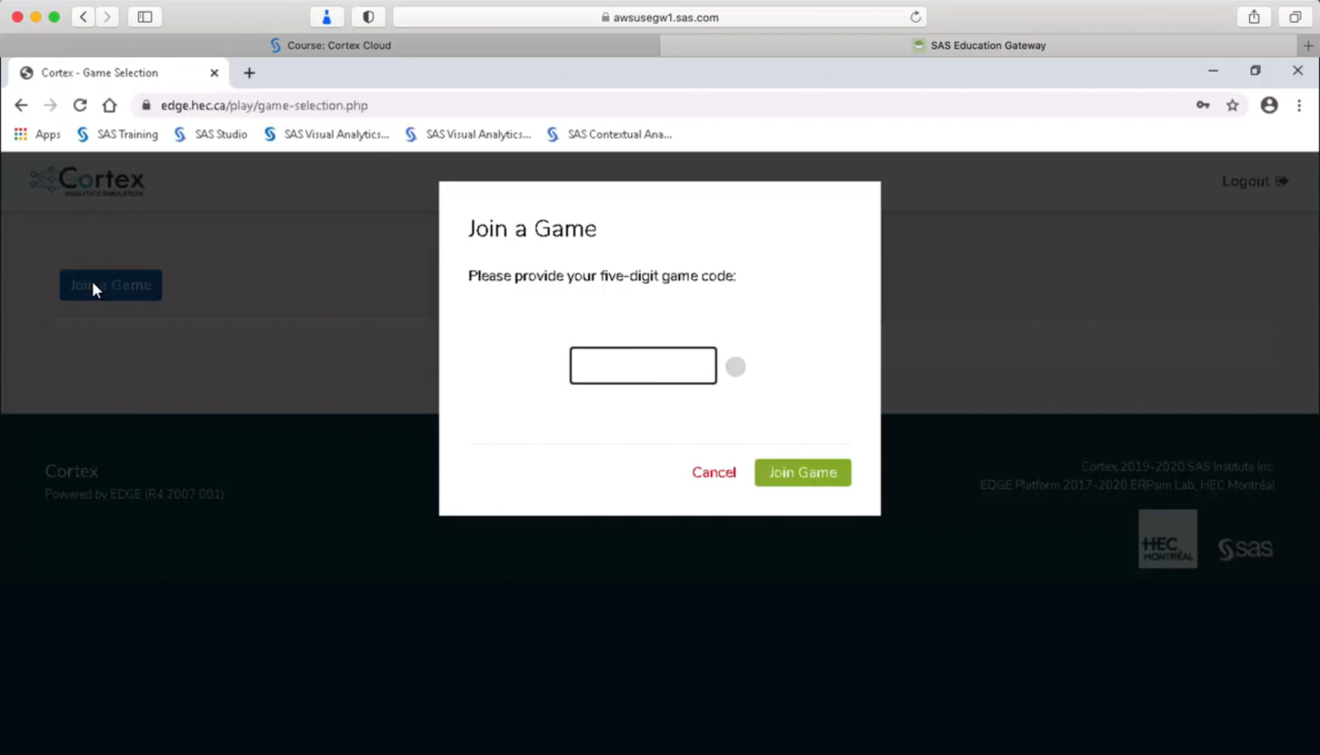

Click the **Play** button to start the game.

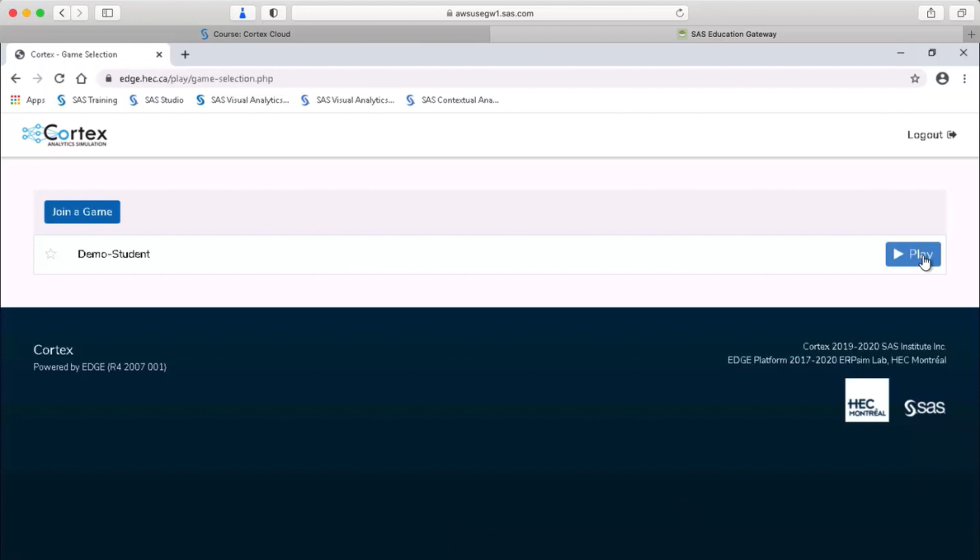

Click **UPLOAD NOW** to upload CSV file.

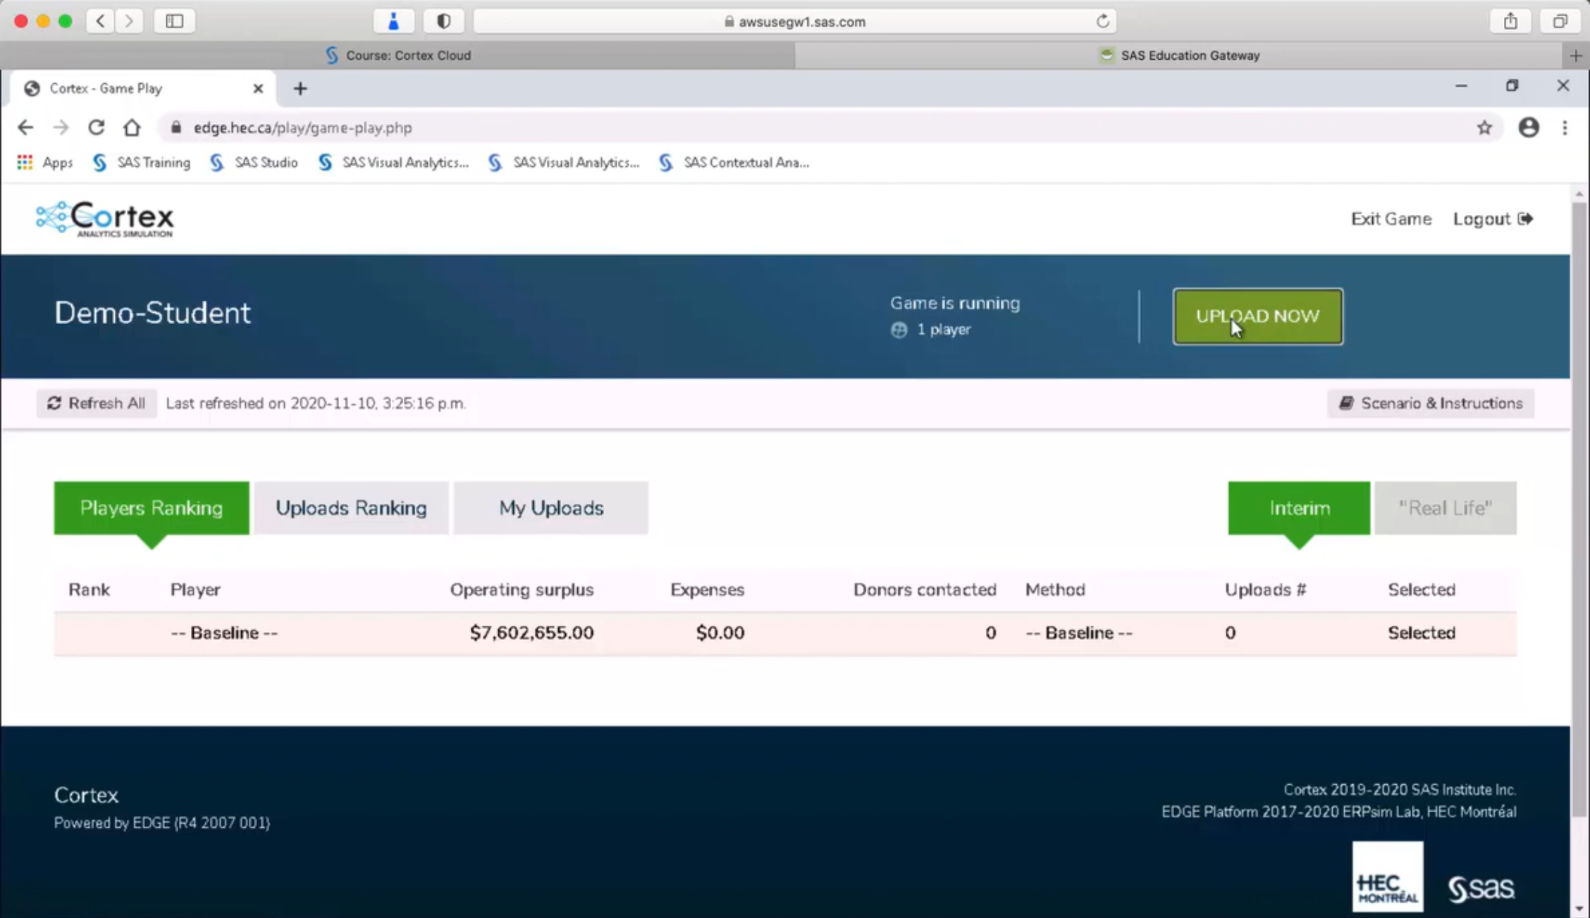

Click **Choose File** button to select your new CSV file, you can name your upload under the **Method used**, and click **Upload decision** button to complete your upload.

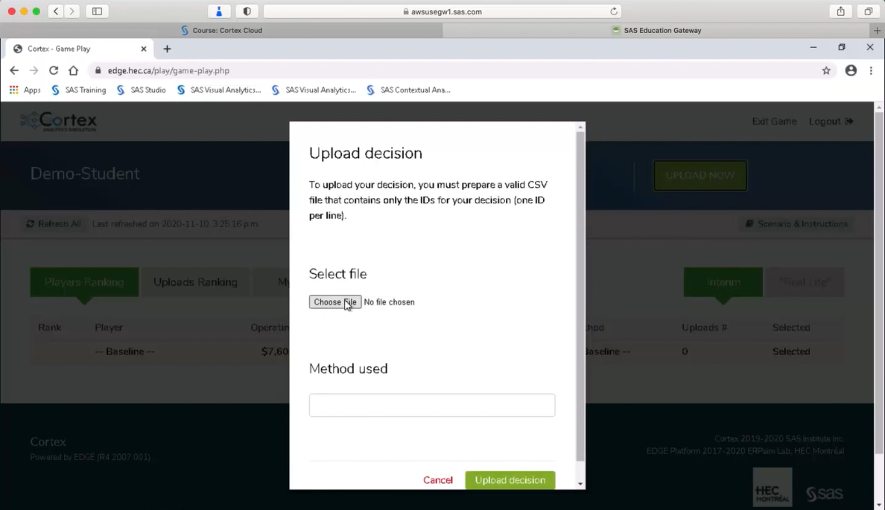

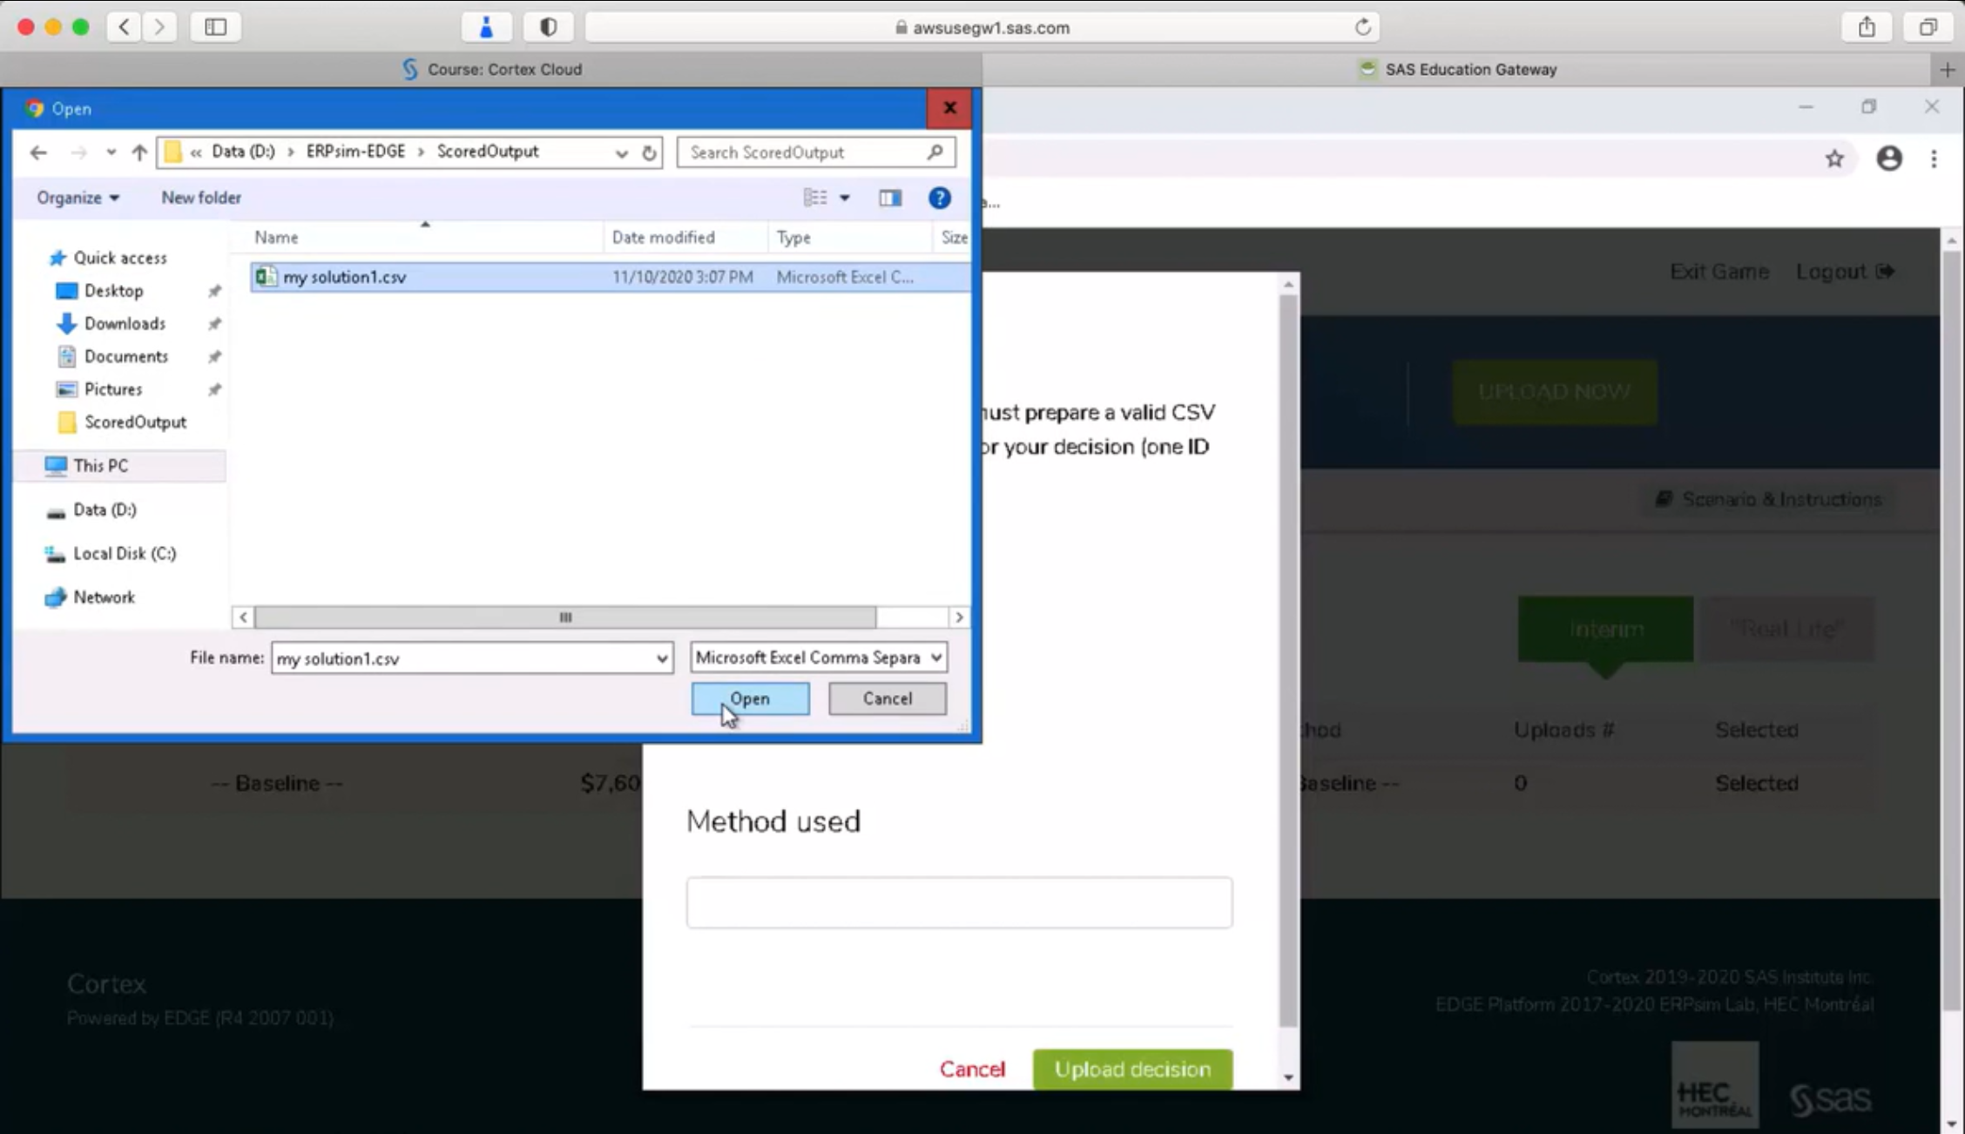

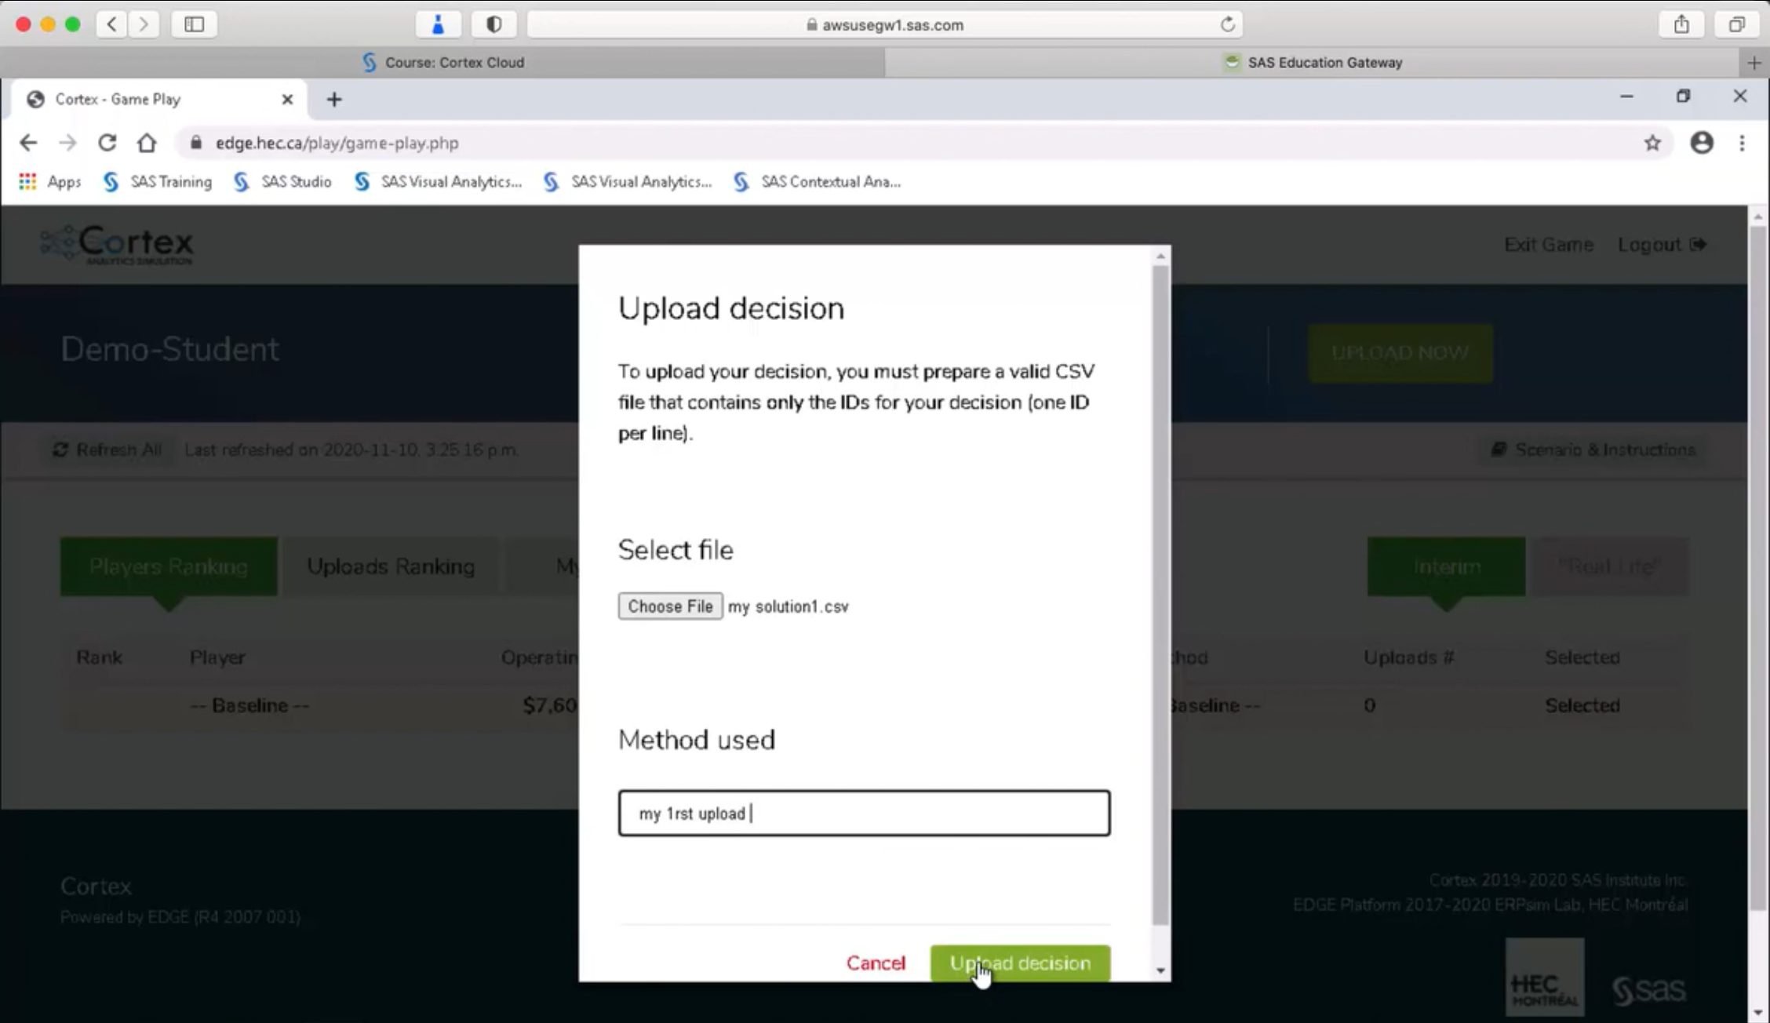

In the main leaderboard: **Players Ranking** tab, you can check the result of the model you choose to upload as well as results uploaded by other players.

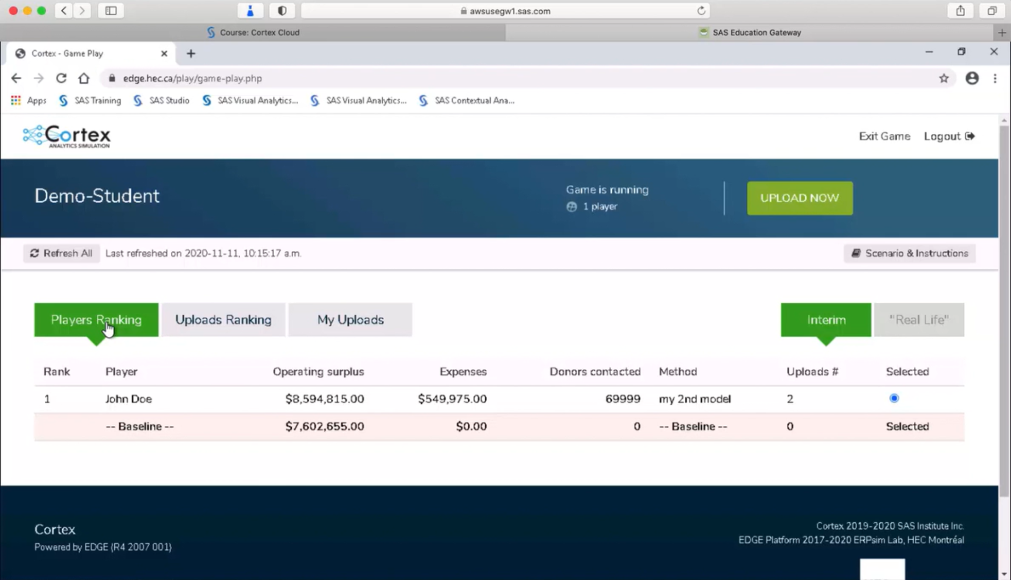

In the **My Uploads** tab, you can see results of all your uploads in the chronological order.

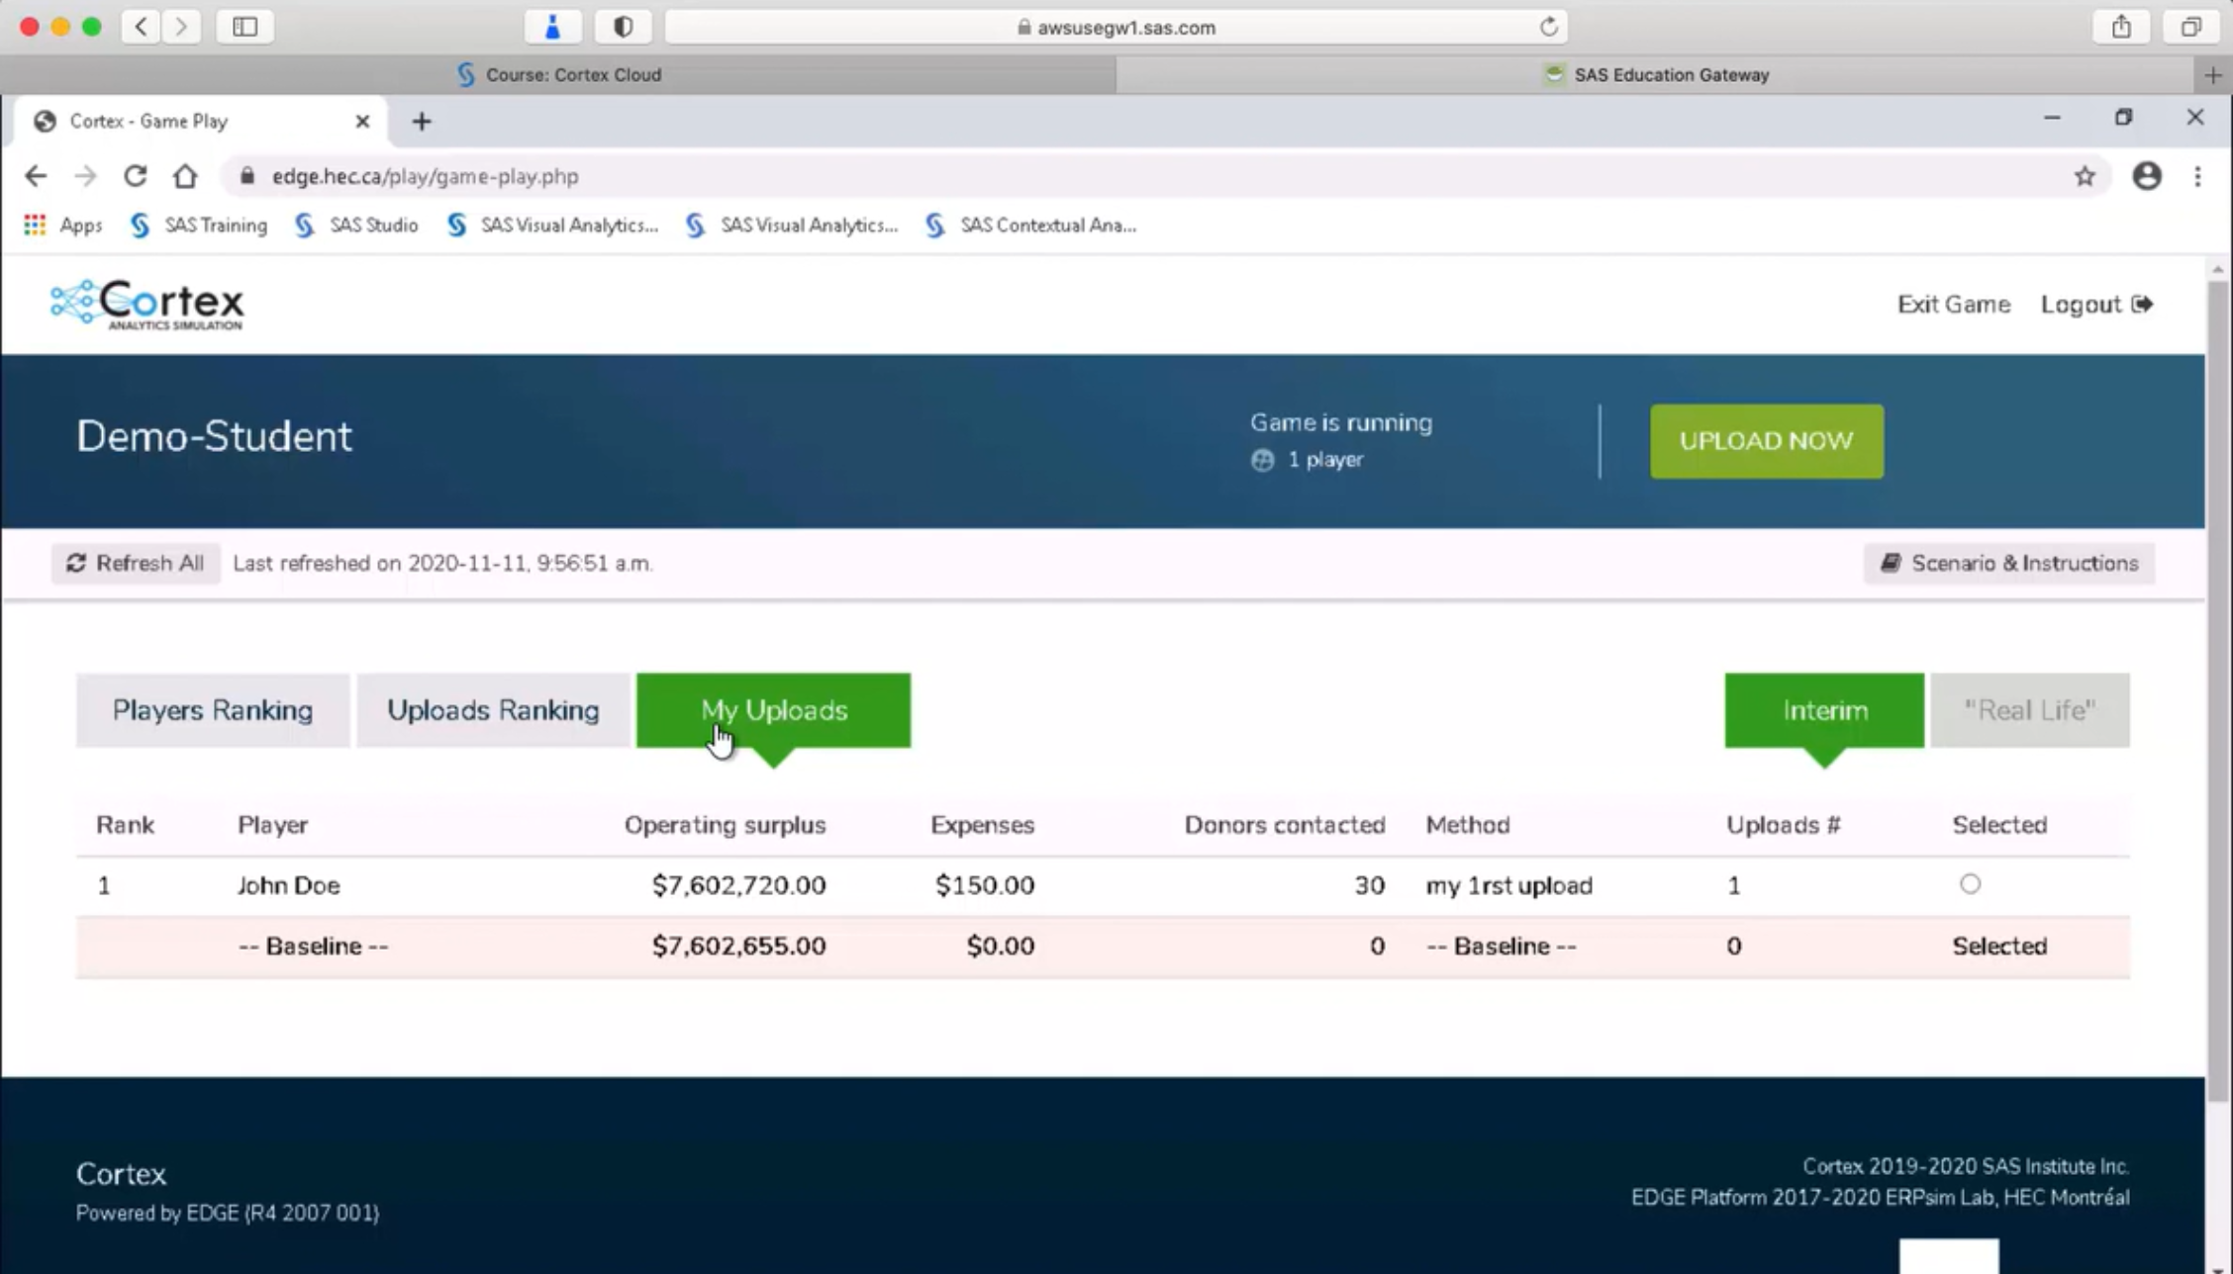

In the **Uploads Ranking** tab to see your uploads’ result based on the Operating Surplus ranking. You can then **Select** one of your uploads with the highest operating surplus and upload to the main Leaderboard, where other players can also see your result.

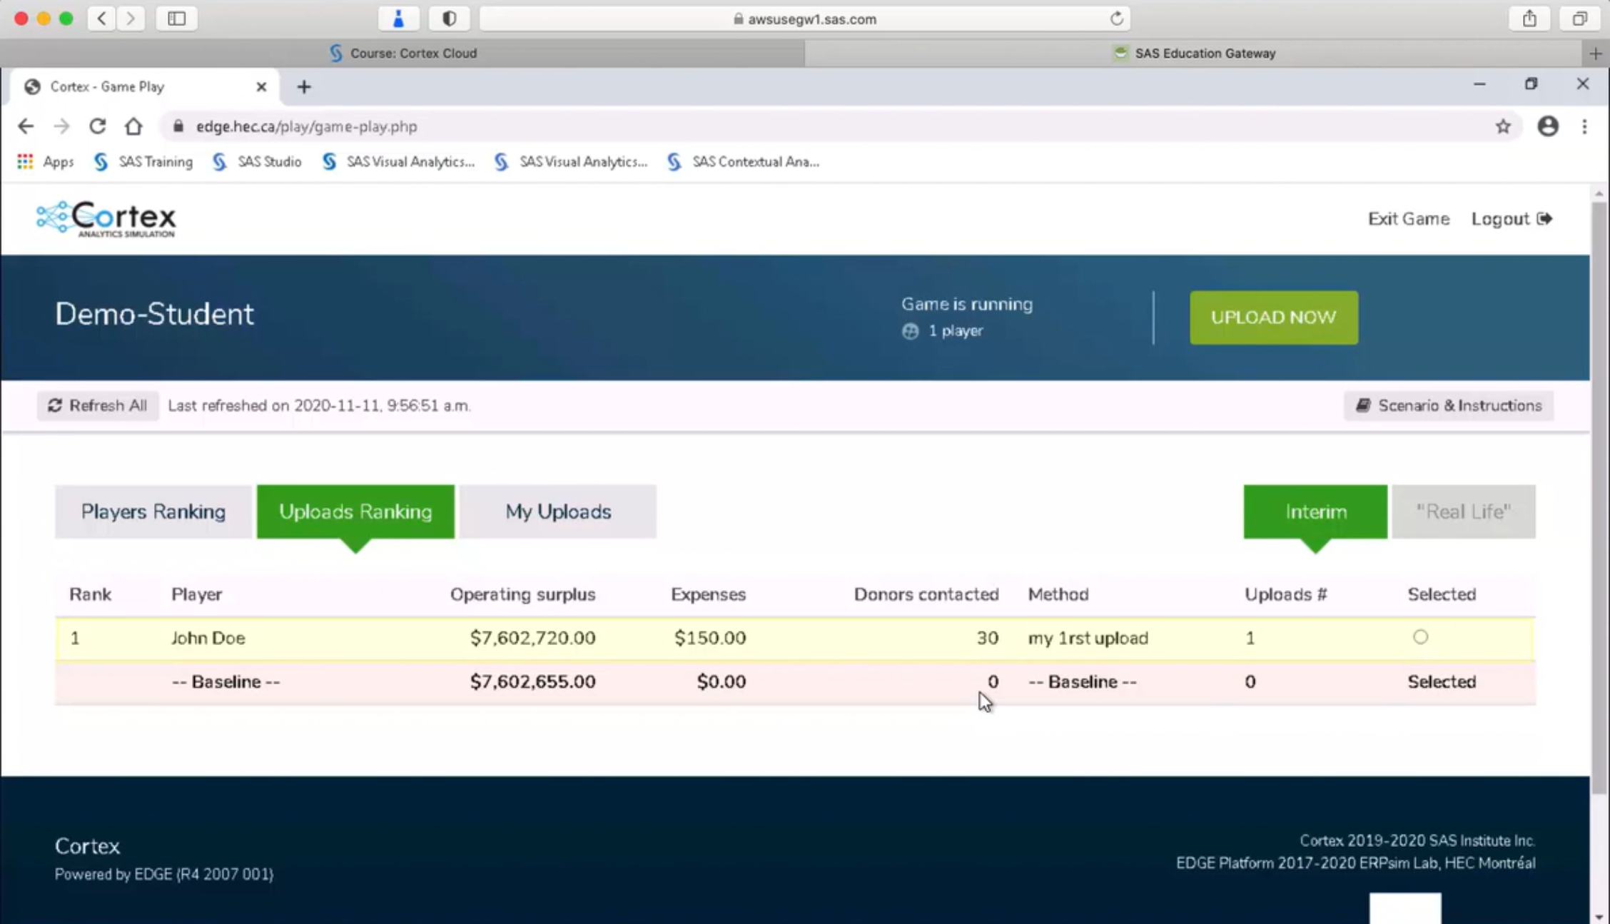

# Round 2 - Game Summary

In Round 2, the foundation still needs help to increase the net amount of the donations. To do so, the effectiveness of the modelling approach should be improved.

One way to improve is to adopt a two-stage modelling approach as below:

1. Fit a model to determine the ***probability P*** that an individual will give
2. Keep only the data of those who gave, fit a model for ***M (the amount gave)***
3. Use both models to make predictions on the population
4. Compute ***P*M*** to determine the ***‘expected donation’*** of each individual

There are many approaches to 2-stage modelling, but in most cases these steps are required to calculate the value of the uplift (hence the uplift modelling):

* + - Predict the expected value if a person receives a treatment (here called or contacted)
    - Predict the expected value if a person does not receive a treatment (here not called or not contacted)
    - Compute the ***difference between the two*** (i.e., the uplift generated by the treatment or targeted action: here the call). The higher the difference is, the treatment (i.e. Contact/ call) is more effective.

# Round 2 – Amount Model Description (SAS)

There are 6 steps for game completion: Data Merge, Data Partition, Model Building, Model Comparison, Scoring Data and Export Results. Check Data Modification for more SAS resources. Note: below is a screenshot of the Cortex flow from SAS Enterprise Miner. This provides a good overview of the analytics processes used throughout the game. It is for your reference only; you will not see this in SAS Studio.

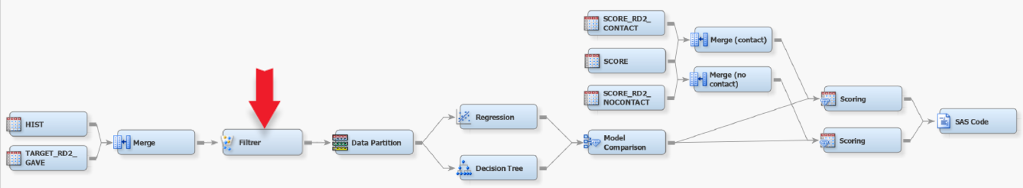

### Step 1: Data Merge

The first step is to merge two datasets into one for better modification. Keep only the data of those who gave (“Gavethisyear” = 1). You need to deal with missing values after merging the datasets so that you proceed can to the next step — Data Partition.

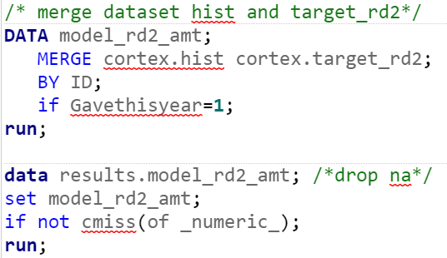

You can use other way to deal with missing values

[Link for Reference](https://documentation.sas.com/doc/en/pgmsascdc/9.4_3.3/statug/statug_surveyselect_toc.htm)

### Step 2: Data Partition

The second step is data partition, this will help the model to increase its performance, please note that this is a default model, you can change the training and validation percentage for a better model performance.

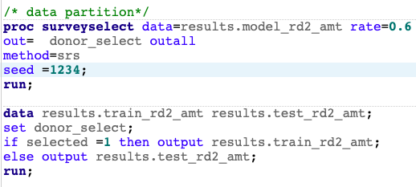

[Link for Reference](https://documentation.sas.com/doc/en/pgmsascdc/9.4_3.3/statug/statug_surveyselect_toc.htm)

### Step 3: Model Building

In this step, [linear regression](https://documentation.sas.com/doc/en/pgmsascdc/9.4_3.3/statug/statug_glmselect_syntax01.htm) and [decision tree](https://support.sas.com/documentation/solutions/emtmsas/94/emprcref.pdf) models are used for analysis, you can also choose other model methods (i.e., [logistic regression](https://documentation.sas.com/doc/en/pgmsascdc/9.4_3.3/statug/statug_logistic_gettingstarted.htm), [HP forest](https://documentation.sas.com/doc/en/pgmsascdc/9.4_3.3/emhpprcref/emhpprcref_hpforest_syntax.htm), [gradient boosting](https://video.sas.com/detail/video/5754395446001/training-gradient-boosting-models-in-model-studio)) to predict the amount donated. We recommend you perform a descriptive analysis to select independent variables for prediction.

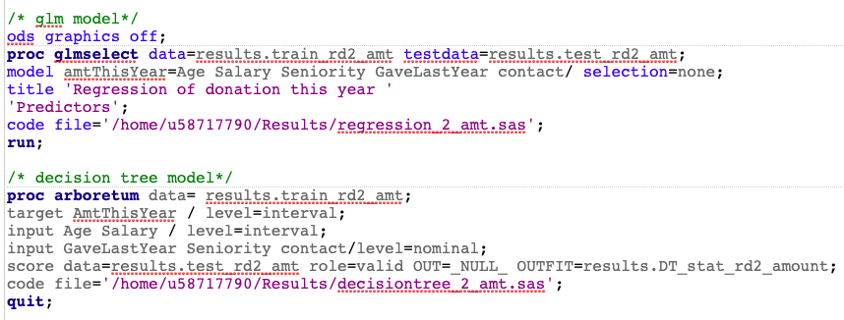

### Step 4: Model Comparison

When comparing models, you can click RESULTS tab for comparison, SAS will compute statistics automatically, you can then choose [different criteria](https://blogs.sas.com/content/iml/2019/01/30/model-validation-machine-learning.html) to determine which model fits better for prediction. In the default model, linear regression model is selected for scoring.



### Step 5: Scoring Data

Scoring new data to compute predictions for an existing model is a fundamental stage in the analytics life cycle. You need to predict the amount of donation next year given the donor is contacted and not contacted. After that, you can export the model result for upload.

Predict donation next year given the donor is contacted

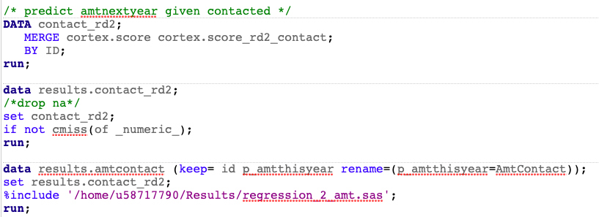

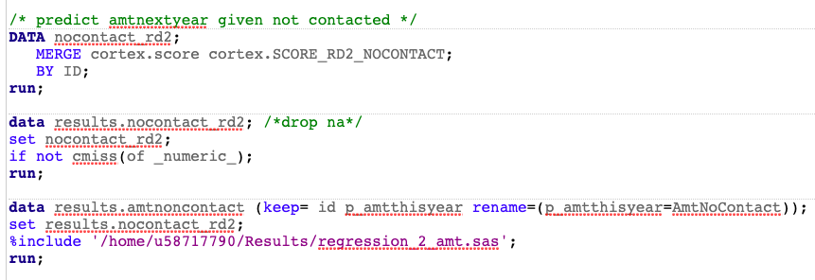

Predict donation next year given the donor is not contacted

### Step 6: Export Results

Merge the two different predictions (amount given contacted and amount given not contacted) by ID, and then export as CSV file. Following code will help you to export the model result into a CSV file.

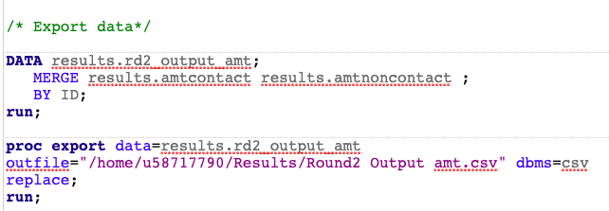

# Round 2 – Probability Model Description (SAS)

There are 6 steps for game completion: Data Merge, Data Partition, Model Building, Model Comparison, Scoring Data and Export Results. Check Data Modification for more SAS resources. Note: below is a screenshot of the Cortex flow from SAS Enterprise Miner. This provides a good overview of the analytics processes used throughout the game. It is for your reference only; you will not see this in SAS Studio.

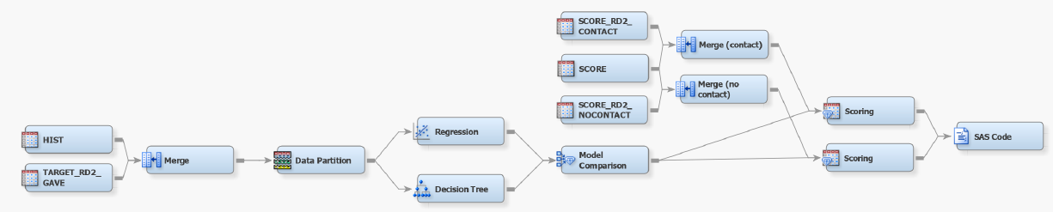

### Step 1: Data Merge

The first step is to merge two datasets into one for better modification. You need to deal with missing values after merging the datasets so that you proceed can to the next step — Data Partition.

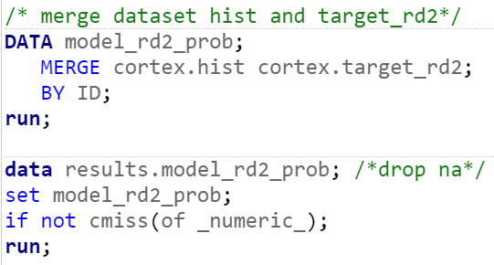

You can use other way to deal with missing values

[Link for Reference](https://documentation.sas.com/doc/en/pgmsascdc/9.4_3.3/statug/statug_surveyselect_toc.htm)

### Step 2: Data Partition

The second step is data partition, this will help the model to increase its performance, please note that this is a default model, you can change the training and validation percentage for a better model performance.

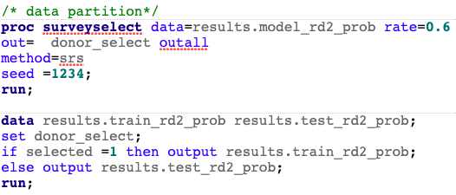

[Link for Reference](https://documentation.sas.com/doc/en/pgmsascdc/9.4_3.3/statug/statug_surveyselect_toc.htm)

### Step 3: Model Building

In this step, [linear regression](https://documentation.sas.com/doc/en/pgmsascdc/9.4_3.3/statug/statug_glmselect_syntax01.htm) and [decision tree](https://support.sas.com/documentation/solutions/emtmsas/94/emprcref.pdf) models are used for analysis, you can also choose other model methods (i.e., [logistic regression](https://documentation.sas.com/doc/en/pgmsascdc/9.4_3.3/statug/statug_logistic_gettingstarted.htm), [HP forest](https://documentation.sas.com/doc/en/pgmsascdc/9.4_3.3/emhpprcref/emhpprcref_hpforest_syntax.htm), [gradient boosting](https://video.sas.com/detail/video/5754395446001/training-gradient-boosting-models-in-model-studio)) to predict the amount donated. We recommend you perform a descriptive analysis to select independent variables for prediction.

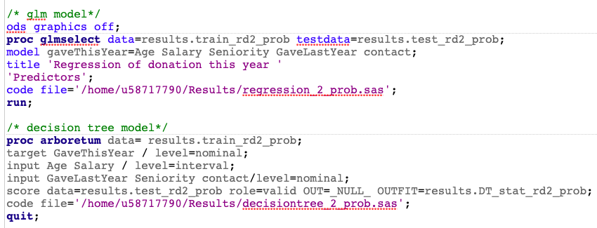

### Step 4: Model Comparison

When comparing models, you can click RESULTS tab for comparison, SAS will compute statistics automatically, you can then choose [different criteria](https://blogs.sas.com/content/iml/2019/01/30/model-validation-machine-learning.html) to determine which model fits better for prediction. In the default model, linear regression model is selected for scoring.



### Step 5: Scoring Data

You need to predict the ***probabilities of donating*** next year given the donor is *contacted* and *not contacted*. After that, you can export the model result for upload.

Predict probability of donate next year given the donor is contacted

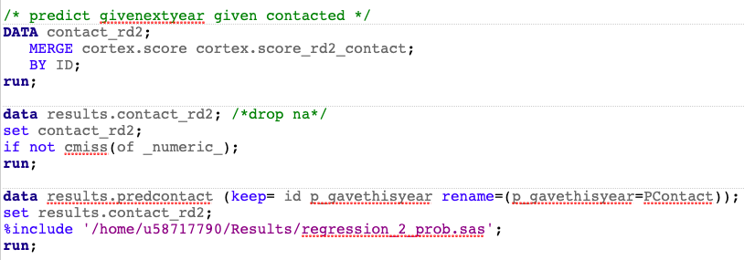

Predict probability of donate next year given the donor is NOT contacted.

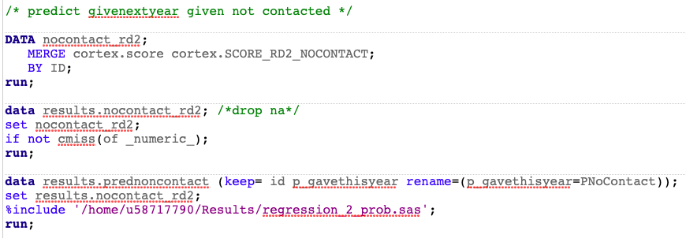

### Step 6: Export Results

Merge the two different predictions (probability given contacted and probability given not contacted) by ID, and then export as CSV file.

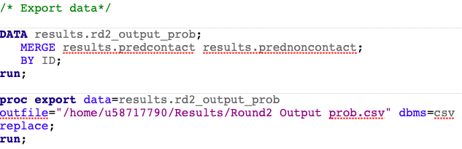

# Round 2 - Amount Model Description (Python)

**NOTE**: You need to install ***saspy, pandas***, ***numpy***, and ***sklearn*** python packages to run the baseline model in your python command.

There are 6 steps for game completion: Data Merge, Data Partition, Model Building, Model Comparison, Scoring Data and Export Results. Note: below is a screenshot of the Cortex flow from SAS Enterprise Miner. This provides a good overview of the analytics processes used throughout the game. It is for your reference only; you will not see this in SAS Studio.



### Step 1: Data Merge

The first step is to merge two datasets into one for better modification. You need to deal with missing values after merging the datasets so that you can proceed to the next step — Data Partition.

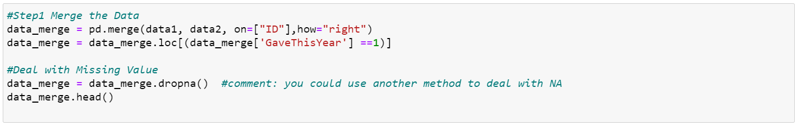

### Step 2: Data Partition

The second step is data partition, this will help the model to increase its performance, please note that this is a default model, you can change the training and validation percentage for a better model performance.

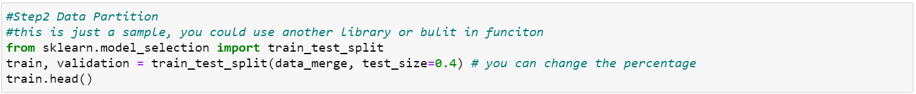

### Step 3: Model Building

In this step, linear regression and decision tree models are used for analysis, you can also choose other model methods (i.e., logistic regression, HP forest, gradient boosting) to predict the amount donated. We recommend you perform a descriptive analysis to select independent variables for prediction.

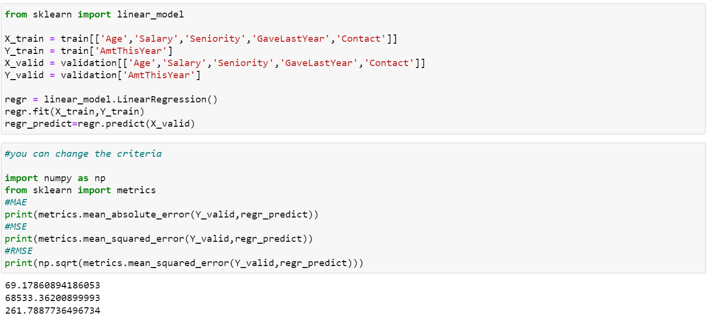

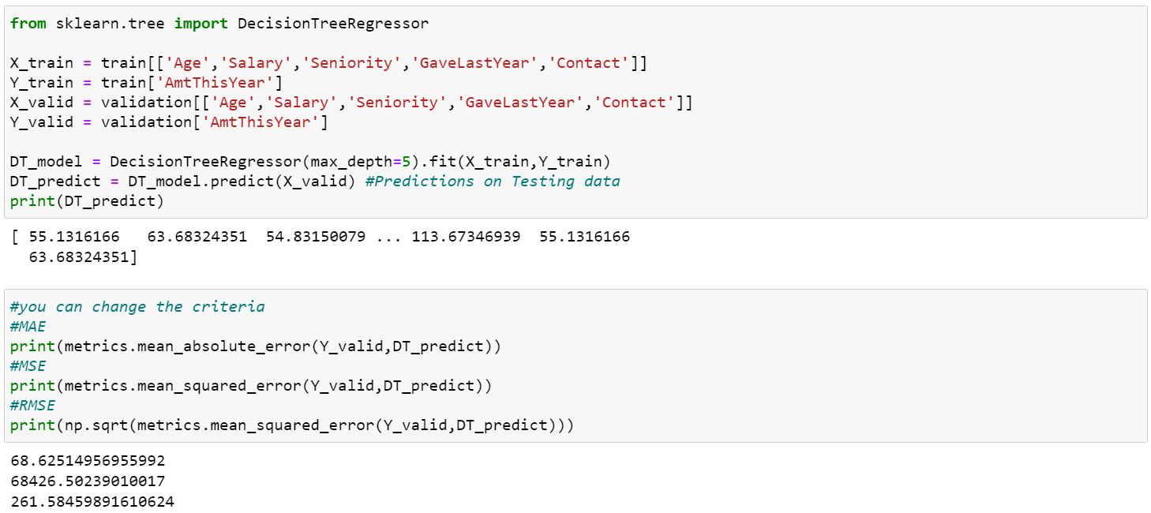

### Step 4: Model Comparison

When comparing models, you need to choose a criterion and calculate it manually to determine which model fits better for prediction since Python will not compute the statistical results automatically. In the default model, we compare the MSE of two model, and the linear regression model is selected for scoring.

### Step 5: Scoring Data

****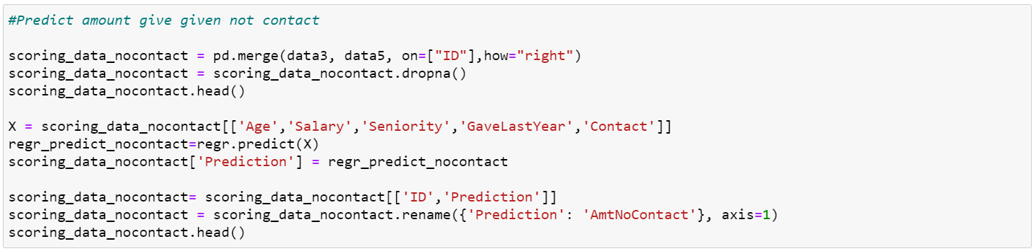Scoring new data to compute predictions for an existing model is a fundamental stage in the analytics life cycle, after you score out the dataset, you can export the model result for upload. 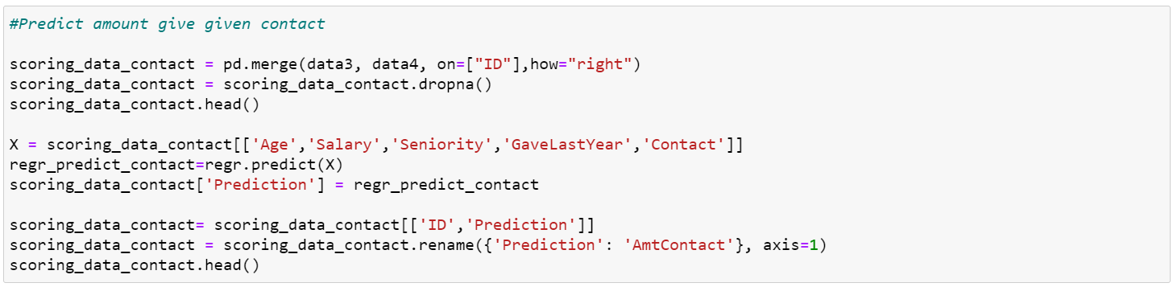

### Step 6: Export Results

Following code will help you to export the model result into a CSV file. You can sort the data by predicted amount in the descending order before export the file, this will help you determine number of donors you want to contact.



# Round 2 - Amount Model Description (Python)

**NOTE**: You need to install ***saspy, pandas***, ***numpy***, and ***sklearn*** python packages to run the baseline model in your python command.

There are 6 steps for game completion: Data Merge, Data Partition, Model Building, Model Comparison, Scoring Data and Export Results. Note: below is a screenshot of the Cortex flow from SAS Enterprise Miner. This provides a good overview of the analytics processes used throughout the game. It is for your reference only; you will not see this in SAS Studio.



### Step 1: Data Merge

The first step is to merge two datasets into one for better modification. You need to deal with missing values after merging the datasets so that you can proceed to the next step — Data Partition.

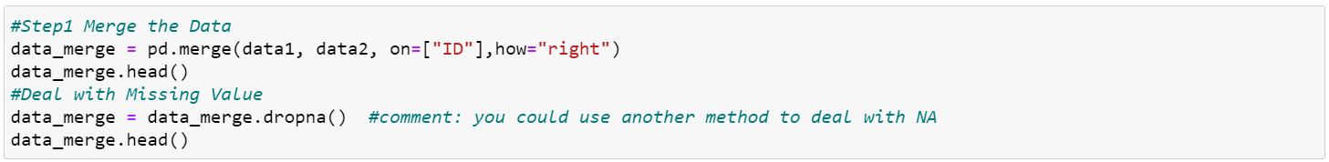

### Step 2: Data Partition

The second step is data partition, this will help the model to increase its performance, please note that this is a default model, you can change the training and validation percentage for a better model performance.

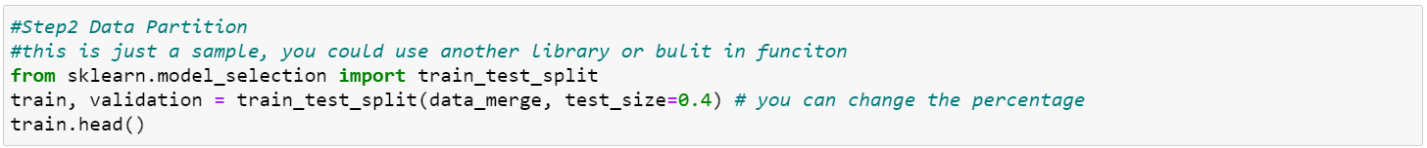

### Step 3: Model Building

In this step, linear regression and decision tree models are used for analysis, you can also choose other model methods (i.e., logistic regression, HP forest, gradient boosting) to predict the amount donated. We recommend you perform a descriptive analysis to select independent variables for prediction.

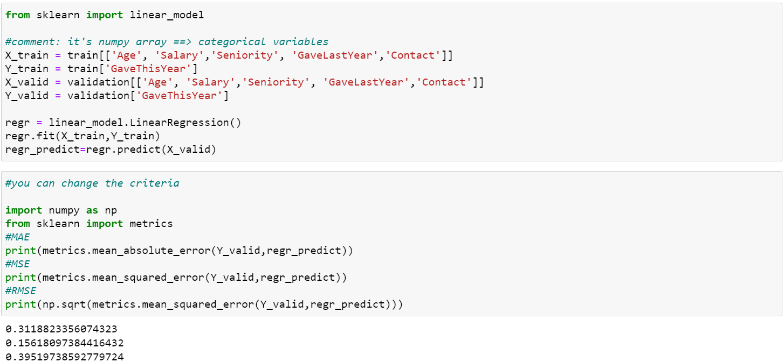

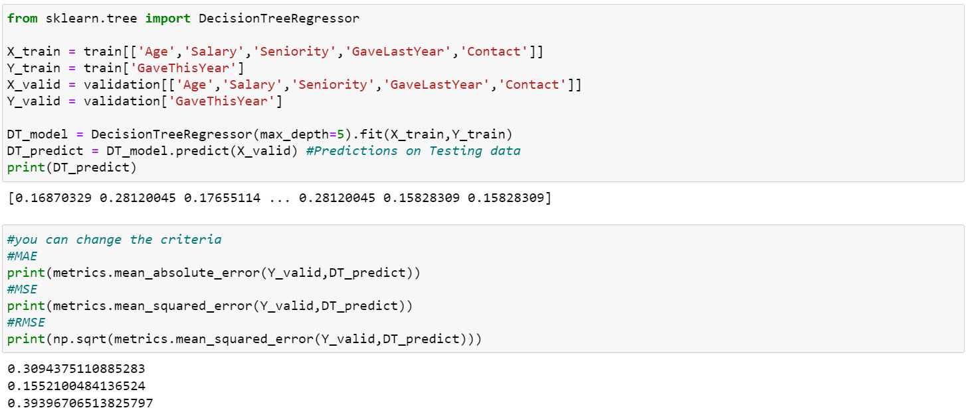

### Step 4: Model Comparison

When comparing models, you need to choose a criterion and calculate it manually to determine which model fits better for prediction since Python will not compute the statistical results automatically. In the default model, we compare the MSE of two model, and the linear regression model is selected for scoring.

### Step 5: Scoring Data

Scoring new data to compute predictions for an existing model is a fundamental stage in the analytics life cycle, after you score out the dataset, you can export the model result for upload.

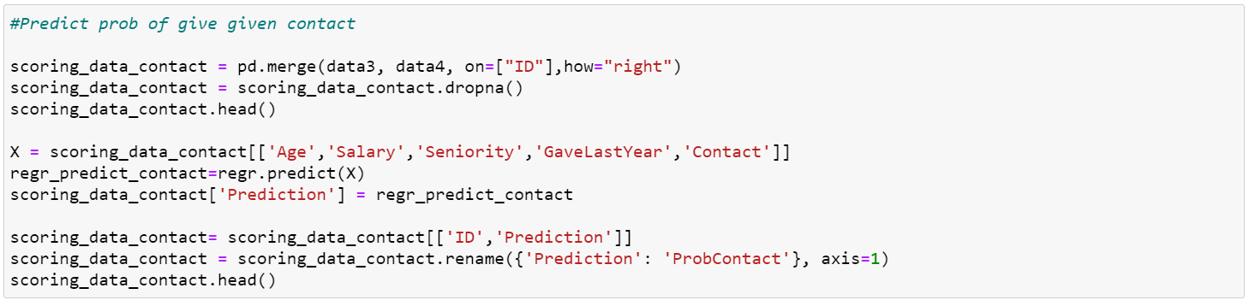 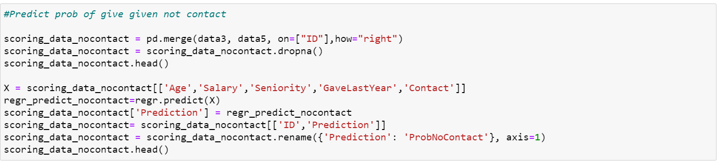 

### Step 6: Export Results

Following code will help you to export the model result into a CSV file. You can sort the data by predicted amount in the descending order before export the file, this will help you determine number of donors you want to contact.



# Round 2 - Upload Decisions

Copy and paste these five columns into a new CSV file.

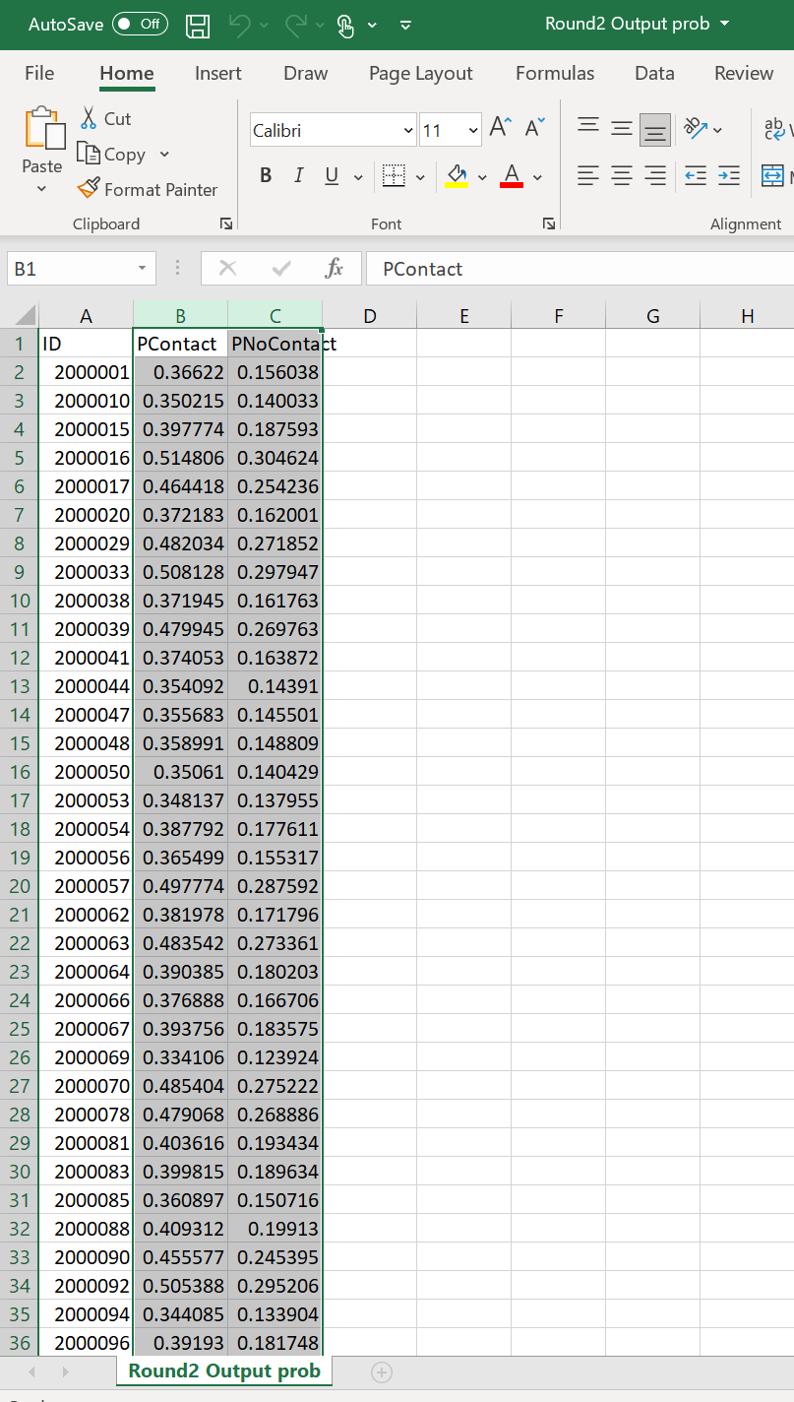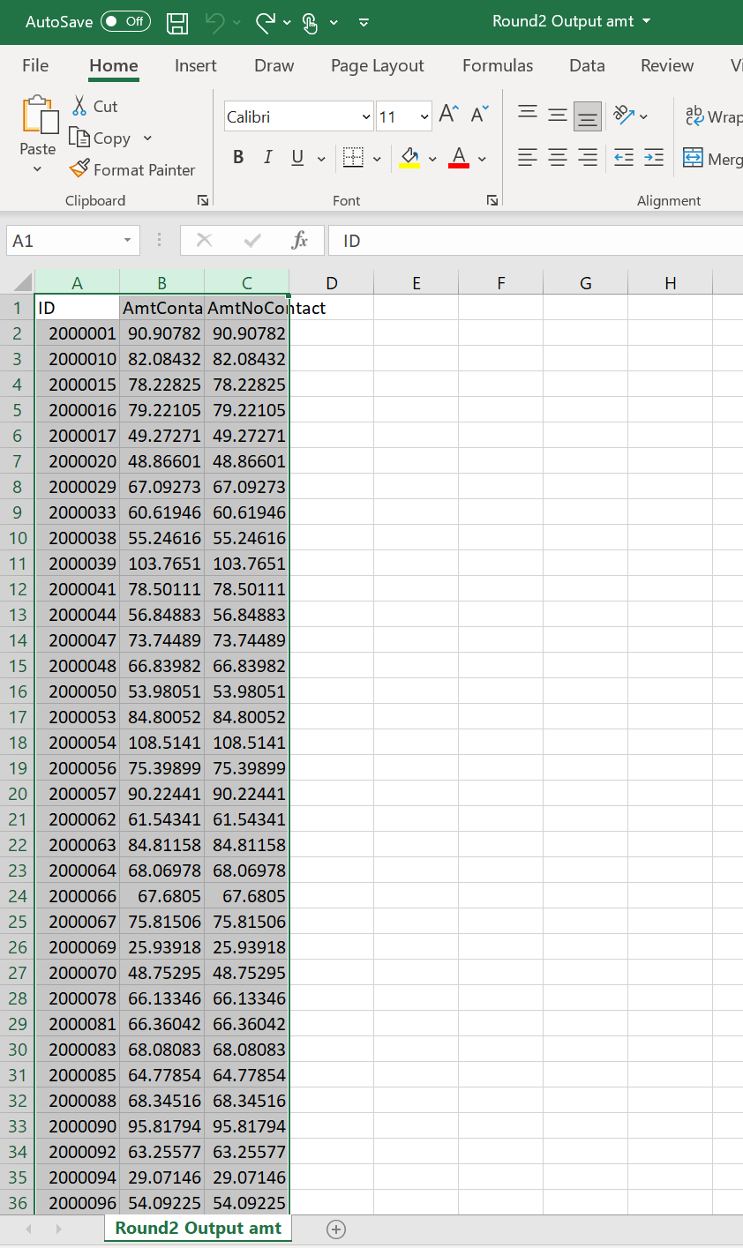

Create a new column names “Expected Donations” and calculate it.

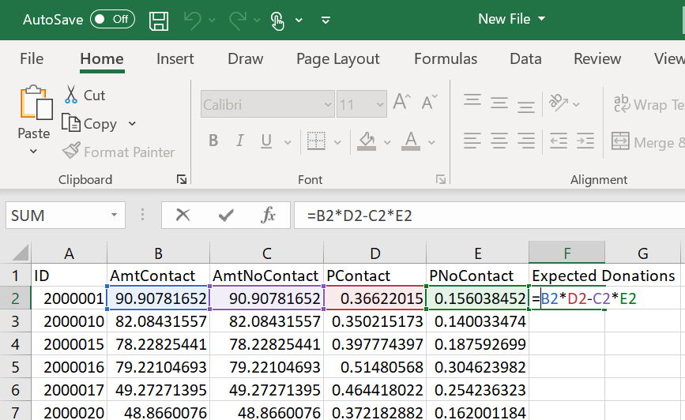

Sort all columns by descending amount of Expected Donations.

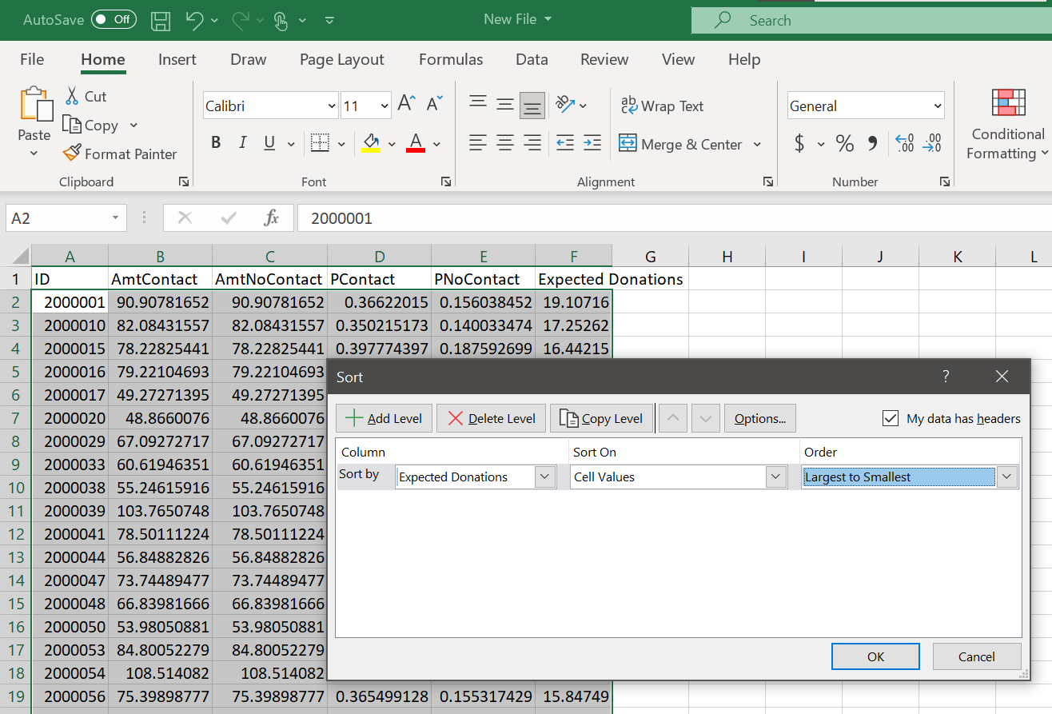

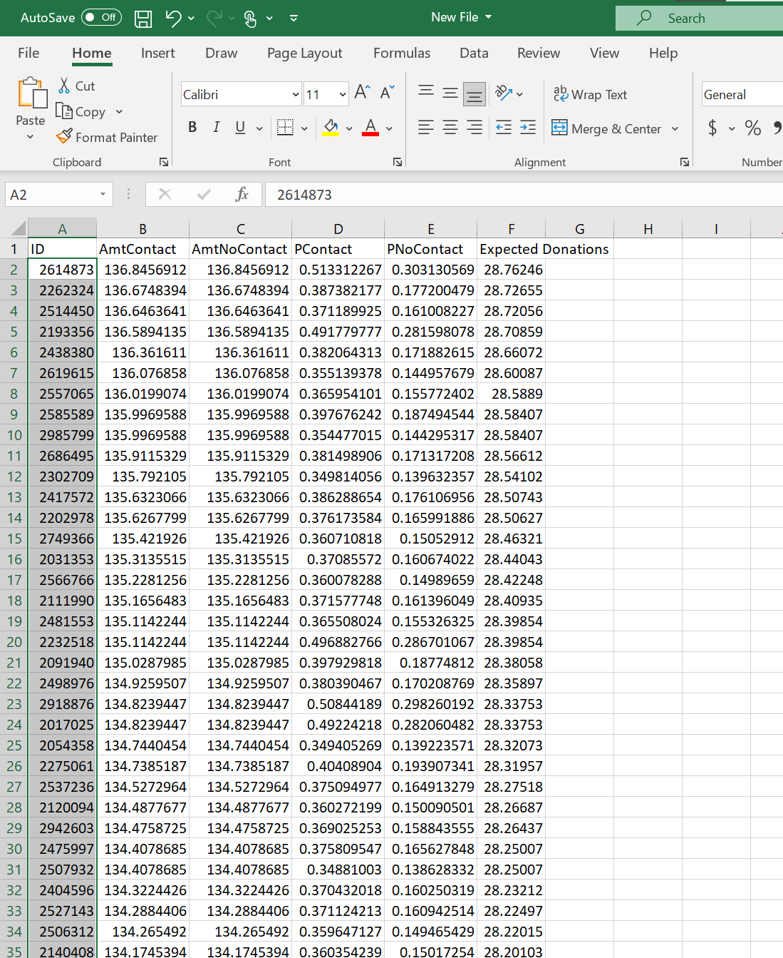Select the number of people ID you want to contact and keep this information in the CSV file for upload.

ONLY keep ID numbers in the CSV file for upload.

Then you can follow the same steps mentioned in Round 1 to upload your model results.

# Dataset Modification:

**Data Exploration:** Click [here](https://support.sas.com/edu/schedules.html?crs=STAT1&ctry=CA#s1=1) to learn how to explore the data and the variables in the dataset.

**Model Comparison:** Click [here](https://www.sas.com/content/dam/SAS/support/en/sas-global-forum-proceedings/2018/2587-2018.pdf) to learn the criteria for model comparisons and pick the model performed best for upload.

**Removing Variables:** Click [here](https://documentation.sas.com/doc/en/pgmsascdc/9.4_3.5/lestmtsref/n1capr0s7tilbvn1lypdshkgpaip.htm) to learn how to remove some of the variables from your models.

**Transform Variables:** Click [here](https://documentation.sas.com/doc/en/pgmsascdc/9.4_3.5/lrcon/p0ya1w48nfc26bn1f04vaeo77i0j.htm) to learn how to transform variables to make them more symmetrical can improve performance.

**Replacing Missing Variables:** Click [here](https://documentation.sas.com/doc/en/pgmsascdc/9.4_3.5/basess/n111c3dt2l1mmmn1svx12jgst36o.htm) to learn how to deal with missing variables in the dataset.